Earth Alliance & Patriot News for June 9th, 2022
By Mark Baughman

Sources: Ted Mahr videos, Q interviews, Gene Decodes live and videos, C-VINE.com, C-Vine News Network, Operation Disclosure, Jared Rand, Skye Prince, Before Its News, Michelle Fielding, Zorra of Hollow Earth, Alex Collier, Dinar Chronicles, Q drops, Benjamin Fulford Website, DoD, Era of Light, and Other Live Conference Calls.

6/9/2022 News: Extremely Hot News; Nick Fleming Key Notes: DoD, Commander Hatonn Message, Matthew Ward Message, Nick’s Video Notes. Articles: Commander Hatonn: US Cabal more Evil Than Atlantis Civilization, Key Notes from Michelle Fielding Video 6/3/2022, Saint Germain: Various Q & A,
Ted Mahr Messages May, 2022, Message from Skye Prince, Iasos; Open Letter to the Top White Hats, Matthew Ward Message: Extraterrestrial Assistance, Ongoing Action, Elon Musk, Earth, Arcturians, El Morya, Mary: Unity Star and States of Sovereignty, Gene Decode with Matt MQ 5/31/2022 Video Notes & W.H.O. DECODE BY GENE DECODETM

Nick Fleming DoD Key Points:

-) Biden Administration has to be removed before the R/V GCR.

-) He was told the Ukraine War will go on another four months. That puts us until September. (Note: the QFS that is in total control of the release, and one major requirement is NO wars on the planet.)

-) He was told Friday Trump will NOT be the next President, even though he is the real Commander-in-Chief now, per the real “Republic of America”, declared by the Military.

-) As per Steve Bannon, Biden will be impeached in November after a “Red Wave” Republican voting wave.” (Many sources say this will happen before then).

-) Zim Bonds, at this time, will be redeemed: know that in a “Lawful World” under a “Restored 1776 Constitution” this Redemption MUST occur. And, it will.

-) It is very possible that Biden is taken down before November with the Hunter Biden Laptop information being revealed by September 2022. Biden has already agreed to step down. Therefore., the R/V GCR could happen before November & NESARA/GESARA with it.

-) If Biden stays in past November, Nick states a very high possibility of Civil War in America! Many millions of Americans with guns know about the massive voter fraud that happened on the November Election Fraud in 11/2020 and will take action.
-) The QFS is in-charge of the release. Those codes have NOT dropped yet. But all 209 countries have “pinged” and connected Central Banks, those codes dropped. All countries are ISO 200022 now.
The War with the Cabal has been Won!! Confirmed by Three Sources! On 6/4/2022
-) By Gene Decode: When Jesus stated “It is Finished”, the battle has been fully Won!! Or called the Greek word “Tetelestai”!
-) By Commander Hatonn: New World Order, which they have worked to gain for the past millennia, is DEAD. The “octopus” with all its tentacles is finished.
-) By El Morya: “June 2022 is a Tipping Point into Sovereignty. June 2022 is a Tipping Point into another Round and Multidimensional Layer of Sacred Sovereignty.”

Saint Germain: Various Q & A
Question 3
When will the new technologies be released such as med beds, replicators, Tesla free energy devices and anti gravitic vehicles?
St Germain: Med beds have already been announced. Of course, it will take time for their use to become widespread and there are certain people prominent within the disclosure movement who are working to produce anti-gravitic vehicles run on free energy.

Commander Hatonn Excerpt:
“I can say that your U.S. Cabal is the culmination of the worst of the Darkside since this planet was formed. The Atlantis civilization was evil, but the U.S. Cabal and all its allies have far surpassed even what Satan could imagine. This is why the battle for Goodness has taken longer than expected, as Earth Shan is a freewill planet.
Many times, the Dark Side has been asked to come to the Light, but they have refused. Now Goodness has come full swing and the Dark Side is not demanding, but begging. There are meetings at the present time of “educating” these evil ones of your evil government, that they are through with their world domination and that the New World Order, which they have worked to gain for the past millennia, is DEAD. The “octopus” with all its tentacles is finished.
There has been very little, if any, word of Truth coming from your controlled, lying media, but they are running scared and are keeping on with the NWO agenda no matter what. The Truth is seeping out and the dam of lies is about to be destroyed, for evil cannot keep on much longer.
I want to give you a word of hope, not despair, a breath of fresh air to know that all is now in proper sequence and timing for Goodness is happening, despite what you see on the lying media and your most evil Communist government!”
______________________________________________

Matthew Ward Message: Extraterrestrial Assistance, Ongoing Action, Elon Musk Excerpt”

“On Earth, the battle has reached crescendo. The Illuminati’s patented covid-19 virus adversely affected the populace physically, psychologically and economically, but it failed to meet their objective of killing billions outright. That made stepping up other activities even more crucial because the low vibrations they need to survive come from others’ fear and pain.
So, they are mightily wielding their sword via their mainstream media and social media propagandists who report Russia’s unprovoked invasion of Ukraine, blame Russian troops for the atrocities and wanton destruction that Illuminati in-country operatives and hired mercenaries commit, and relay the fabricated speculation that Russia will steamroll through Ukraine and onward to conquer other countries.
The deceived public doesn’t know Russian troops, acting in consonance with light forces, took on the essential task of destroying bio-weaponry intended to eradicate most of the world’s people. They don’t know the troops are uprooting decades of Illuminati control in Eastern Union countries and eliminating laboratories and storage facilities, production and storage of chemical weaponry, and headquarters of sex trafficking, money laundering and worldwide computer hacking. They don’t know the troops are exploding tunnels and compounds after rescuing babies and little children held captive until they are shipped wherever ordered by pedophilia rings and for satanic rituals.
Yes, we have spoken about that before, but it bears repeating because many of those activities are commonplace in several countries. Ukraine may have had the Illuminati’s most extensive range of entrenchments, but they have clandestine operations and operatives elsewhere, too, most notably perhaps the United States, and, just as in Ukraine, it is without the awareness of the citizenry and the world public. Eventually that information will become known as will activity ongoing behind the scenes, including arrests, trials, executions and other killings of principals in that diabolical global network.
Dear ones, if there were another way to end pervasive darkness, Gaia and all other light beings would devoutly wish it to be, but there is not, not with the depth and breadth of demonic activity. There is no way to negotiate with an element of society that works secretly to achieve its goal to exterminate most of the population, make hybrid robotic servants of survivors, and continue jeopardizing the life of the planet. There is no way to negotiate with an element that has descended into such a density of depravity that they exist by indulging in unconscionable crimes against humanity.
The public, steeped in deception, is completely unaware of any of that and many thoughts are “send military arms to Ukraine” and “defeat the Russians.” Such thoughts are keeping violence going and that is exactly what the Illuminati want. They know this is a battle between them and the light forces and they have become desperate.
The fear factor in daily reporting of greatly inflated case and death statistics of covid and its mutants lost steam as the peoples wearied of restrictions and started regaining control of their lives. Since the dark ones require the energy of fear to sustain themselves, always they have action afoot that will create fear in at least part of the populace. Now it is “vaccines” soon to be available for infants, World Health Organization’s legal authorization to take whatever action they claim is necessary in the interests of world health, and a few cases of monkey pox popping up in different countries.
Let us dispel any concerns you may have about those situations. Scientists in the extraterrestrial special forces rendered as harmless as possible toxins and erased programming in the nanochips in the solutions falsely called vaccines for babies and young children. Not only would WHO not have the hundreds of thousands they would need from local to national levels to enforce compliance with any edicts, but backlash would be too formidable to handle. And, nothing at all in Earth’s energy field of potential indicates that monkey pox could become the newest “pandemic.”
However, just as the populace doesn’t know the truth about what is happening in Ukraine, they don’t know the truth about the aforementioned situations, either. Consequently, their collective thoughts about all of those matters are producing negativity’s low vibrations that are like fortresses between their focused attention and spiritual and conscious awareness. While this isn’t delaying Earth’s ascension—she is steadily orbiting into successively higher astral planes—it is delaying her people’s awakening.”
_________________________________________________________

Earth, Arcturians, El Morya, Mary: Unity Star and States of Sovereignty Excerpt: (We are Getting There, Hang in There!)

“Sovereignty is a State of Being, and a State of Grace Within. You empower it with your breath and your conscious attention.” Sovereignty is an Inner State of Being that is LIFE GIVING. It is always granted. It is an eternal state and way of being, that is ever flowing. And ever abundant. And Source Knows This. It is time for you to know this again. “

Nick Fleming DoD Video Notes 6/5/2022 & 6/6/2022

No overall News, but Nick Fleming did get a personal visit from the Military on 6/4/2022, that is why he did not have a call Friday night. He cannot release all what was stated but did reveal many things:

Nick Fleming Key Points:

-) Biden Administration has to be removed before the R/V GCR.

-) He was told the Ukraine War will go on another four months. That puts us until September. (Note: the QFS that is in total control of the release, and one major requirement is NO wars on the planet.)

-) He was told Friday Trump will NOT be the next President, even though he is the real Commander-in-Chief, per the real “Republic of America”.

-) As per Steve Bannon, Biden will be impeached in November after a “Red Wave” Republican voting wave.” (Many sources say this will happen before then).

-) Zim Bonds, at this time, will be redeemed: know that in a “Lawful World” under a “Restored 1776 Constitution” this Redemption MUST occur. And, it will.

-) It is possible that Biden is taken down before November with the Hunter Biden Laptop information being revealed by September 2022 or before. Biden has already agreed to step down. Therefore., the R/V GCR could happen before November & NESARA/GESARA.

-) If Biden stays in past November, Nick states a very high possibility of Civil War in America! Many millions of Americans with guns know about the massive voter fraud that happened on the November Election Fraud in 11/2022 and will take action.

-) The QFS is in-charge of the release. Those codes have NOT dropped yet. All 209 countries have “pinged” and connected Central Banks, those codes did drop. All countries are ISO 200022 now.

Notes: Overall, the R/V GCR will HAPPEN, we just do not know WHEN? We are not in control, too!! We are in a situation, that certain information is allowed to leak behind closed doors. They only leak what they want currency holders to hear. This will break, and the R/V GCR is our future!! Stop looking at the “Smoke or Mirrors” by CIA fronts.

Every time they talk about, they something, like in the November elections, it DOES make a difference.

We will sign an NDA during the redemption visit, and its main point is: you cannot tell the amount or the percentage you got! Other people may have more/or less, this creates issues. Most are 90 days; some is five years.

Wells Fargo & Redemption Centers cannot tell anything what is going on, except when they are working, against their NDA.

You can trust the redemption center people; they are all bonded. If you ask to look at the Screen as far as they rate, they are required to turn the screen and show you all the current exchange rates.

Crypto has nothing to do with the QFS, and R/V GCR, only countries’ currencies will be exchanged. In the QFS, though except that XRP and XLM will be asset backed and is part of the running of money transfers, is all.

All money from all Global Collateral Accounts (six of them) is now sitting on the QFS.

The World Court put Tier # 4B, the humanitarians, normal people, and American has the largest currency holders in the world.

There are 12 General in the DoD making decisions for the military action, (Nick says part of the problem) of the White Hats. Also, there is a Committer for the R/V GCR release, but the QFS and it’s A.I. makes the decisions of the timing of the R/V GCR, that is why, they keep stating Nothing Can Stop What is Coming! No person on the planet can stop the R/V GCR.

The Debit card given to people, will carry them over for the first 90-Days, until say for example, if you wanted a structured payout.

You will be able to make appointments for the redemption centers for 90 days, Not the 10 days you have been hearing about, that is old news and it has changed.

You can have one major account or set up multi-accounts, it is your choice.

Biden and the secret corrupt government behind it (Deep State) wants to make America into a third world country.

All exotic Bonds, have been turned in. Money is not released, bond money is SKR’s.

Reno situation, the part of Admiral Bob’s group, Nick says is controlled by CIA, do not listen to their intel either. They are moving that operation to Texas, now.

Now on the FAKE Intel People: Putting out Bullshit: Charlie Ward, Paul Simon, and Kim (Possible) Goguen is CIA operations and with the Major Part the R/V GCR is, there is agents to GO AGAINST the R/V GCR from happening, normal war tactics. DO NOT LISTEN TO THEM! They only care about themselves, to make money, you listen to them, you give them money.

Judy Byington is saying the Charlie Ward is head to the R/V GCR, makes NO SENSE at all, he is making 1 million a month on his You-Tubes and “inter-circle” paid information and it is BOGUS, big time. Charlie own son produced a video how big of Narcissist he is. He is only interested in money, and more than one person in the know, has stated that. He has NO security at all, and no one person will be put in-charge of something that is so important, common-sense, PEOPLE!

Ron Giles, fake information and saying the Zim Bonds are going.

Mark Z, just is about the same, Nick Fleming has talked to him and still believes a seventy some year-old man, retired from the Bush Administration years, with NO security at all will trigger the codes for the R/V GCR. He was written out of R/V GCR years ago. NO ONE PERSON HAS SAY OR THAT MUCH CONTROL OVER THE R/V GCR, You, got it now? The security that the Alliance has to have. Use common-sense!

C K 🌈🌈, [6/7/2022 12:31 PM]

[Forwarded from Nick Fleming]

China and the Zim Redemption Swap

If the global RV GCR started today, Nick Fleming has made it very clear that the Zimbabwe Bond Note is “off the table”. That no Tier 4 participants can possibly benefit further from the hundreds of thousands of 100 T and 50 T Zimbabwe Government Bond notes purchased for the Tier 4 Redemption/Exchange Center event that we’ve heard about for years and years. Many of these Tier 4 ZIM holders have been waiting for this event since 2014. A lot of dreams, hopes and ambitions are invested in these pieces of funny-money-paper. For a good reason too.

Zimbabwe participated in this Great Global Financial Shift for the purpose of “a massive currency swap.” Out with the old, in with the new Zim Dollar. The 100 T Zimbabwe Government Bond note states right on the front of the note: “I PROMISE TO PAY THE BEARER ON DEMAND ONE HUNDRED TRILLION DOLLARS FOR THE RESERVE BANK OF ZIMBABWE”

The Reserve Bank of Zimbabwe participated when the Zim Bond note was put into a trade platform in Hong Kong. The Reserve Bank of Zimbabwe supported the (Lloyd’s of London) insurance wrap/guarantee of $18 Million US dollars per 100 T note valuation. So did tens of thousands of individuals, all receiving a commitment of (wasn’t it whispered?), a share of proceeds which were also valued at a minimum, $18 million US dollars per 100 T note? If this is the case, then how did the Zimbabwe Bond Notes suddenly become valueless?

Plain and simple, Zimbabwe Bond Notes were usurped. The Government of Zimbabwe, and the Reserve Bank of Zimbabwe, have signed an exclusive deal with the Chinese Government, which has locked up the ‘right to trade/swap the Zimbabwe Bond Notes’. Any other entity or country, or broker, or party attempting to facilitate any sort of a trade involving this Zim Bond Note, has to deal with China. Can this US Government deal with China?

There’s precedent here. Seems like a discussion made for arbitration or the courts. There’s historic precedence and years of false information shared, presumptions supported, innuendo and stories spread far and wide. But by what entity? Could it be that this was led by the Zimbabwe Central Bank? Or possibly, the same people involved in this Global Currency Treaty? Certainly, the US Treasury is culpable and involved in a CABAL of betrayal and treachery – to be kind. To the hundreds of thousands of believers participating in this Zim Bond Redemption theme this betrayal is unforeseen, unexpected and terrible, terrible, impossible to believe.

The Zim Bond Note was purchased with the explicit statement “ALL NOTES ON THIS SITE ARE COLLECTIBLES ONLY. THEY ARE DEFUNCT CURRENCY, NOT LEGAL TENDER AND NOT INVESTMENT PRODUCTS.” So what? This “no value” bond was actually insured by a leading re-insurance agency. This entire RV GCR scenario carries implausible currencies, with projected values in “ridiculous” and eye-rolling amounts. AND which have historically been reported to have already been traded for these same implausible amounts.

This is the same “plausible deniability” that is the sickness of this decade. Covered by privacy agreements, by hidden agendas, and by cowardly “authorities,” unwilling to speak clearly with the conviction of the office for which they serve. Instead this is the chronic CYA necessary in a sick world.

Plausible deniability is the go-to action of choice for the Committee of Generals, speaking half-truths to Nick Fleming, and not allowing him to share the full facts as they stand, with One and All. Plausible deniability is also the go-to for the Chinese Elders, accusing the US Treasury of not delivering on its commitment and withholding the Zim Bond Notes Redemption, in retribution. Plausible deniability is the go-to for every “authority” involved in this Quantum Shift, from Light to Dark and from Slavery to Freedom. This crime of “plausible deniability” can continue only so much longer. For immediately once the Shift hits, and it will, these weak, self-protecting actions will be brought to Light.

C K 🌈🌈, [6/7/2022 12:31 PM]

[Forwarded from Nick Fleming]

To all taking the lesser path – the path of least resistance, choosing to CYA, instead of actually Be the Change You Seek; there will be the Devil to Pay.

To all who hold Zimbabwe Government Bonds, know that in a “Lawful World” under a “Restored 1776 Constitution” this Redemption MUST occur. And, it will.

Plausible deniability be dammed.

Zorra Call 6/4/2022

That all the Whales have exchanged. Understand to be patient. Think that it has already happened. Sheldon says the rates are high. Zim is going to be an important part of the R/V GCR. All countries are going to be 1 to 1, to each other, that is the goal, all asset backed too.

We are going to Digital Currency on the QFS system. It will never crash. The old fiat currency and stock market will eventually crash, but do NOT think until the new QFS is started and everyone has secure money, and transactions.

Zorra on the Adam & Eve Story, Eve was born first, and men stayed home before. The Dead Sea Scrolls is the original Bible, until the Catholic Church and the Council of Nicea changed all, and hid 711 chapters or books of the Bible, 66 chapters or books were released, only. The Catholic Church keep the un-released ones under the Vatican. What happened to the human race and the genetic manipulation happened when the Annnunaki came to this planet, and made us into a slave race, and bred the genetic mix into, some of the elites into an un-caring, un-empathetic, and killing race of beings.

Commander Hatonn: US Cabal more Evil Than Atlantis Civilization
Posted on 06/06/2022
I have called you to the computer, Anne, and have requested a communication.
Anne: Thank you Hatonn. I am humbled that you have called for a communication. Please give us the message you wish us to hear.
Hatonn: I have a short message to give to the Lightworkers, who are my Ground Crew. I say to all of you, do not give up, nor think that all is lost to the Darkside. God’s Plan 2000 is in full swing, and the final hours of the Darkside are at hand. The battle has been long and arduous with many hardships, rocks in the pathway, and twists and turns that were not expected; however, know that Creator God always wins!
There have been promises broken, written contracts abolished, plots and terrorist attacks attempted, even to the destruction of Mother Earth by the Dark Ones. There has been no stone left unturned by the Darkside in their attempt to control this planet, or else destroy her, as they have done to other planets in your solar system and beyond. As you know, Earth Shan has been the jail planet for Satan and his minions, and they have done their job well in controlling this planet since the beginning of the 20,000 civilizations. There have been endless wars and destruction of millions upon millions of people, as these Dark Ones have come back life stream after life stream to continue their goal of world control.
I have written in the Phoenix Journals how these tricks have been played upon mankind, who has been “as blind as a bat”; however, during these last very few years since 1989 when the first Journal was penned, there have been many, who have awakened to the Lie, and are seeing for the first time the tricks of the Darkside. Many are still in “kindergarten”, but there are warrior Lightworkers, who have tried very hard to awaken others to the Lie under which people have been living and have cleaned much evil form Earth with the help of Sananda.
I can say that your U.S. Cabal is the culmination of the worst of the Darkside since this planet was formed. The Atlantis civilization was evil, but the U.S. Cabal and all its allies have far surpassed even what Satan could imagine. This is why the battle for Goodness has taken longer than expected, as Earth Shan is a freewill planet.
Many times, the Dark Side has been asked to come to the Light, but they have refused. Now Goodness has come full swing and the Dark Side is not demanding, but begging. There are meetings at the present time of “educating” these evil ones of your evil government, that they are through with their world domination and that the New World Order, which they have worked to gain for the past millennia, is DEAD. The “octopus” with all its tentacles is finished.
There has been very little, if any, word of Truth coming from your controlled, lying media, but they are running scared and are keeping on with the NWO agenda no matter what. The Truth is seeping out and the dam of lies is about to be destroyed, for evil cannot keep on much longer.
I want to give you a word of hope, not despair, a breath of fresh air to know that all is now in proper sequence and timing for Goodness is happening, despite what you see on the lying media and your most evil Communist government!
I have no exact minute for Lift-Off, but know that we are on Red, High Alert and monitoring Mother Earth quite closely. You are to keep keeping on, as if you had much time, as no one should sit back and say, “Oh, Mother Earth is going into 5th Dimension, and I have nothing about which to worry.”
I commend the Lightworkers for all they have done to help Mother Earth. Keep working at your contract until the very end. Do not give up hope, but know that the Darkside has been defeated, although you do not see much evidence. Petition for Mother Earth, for all Lightworkers and stay strong. Victory is here! The Light has won!
I thank all of you Lightworkers, who have kept the faith. After all, you came here for soul growth, and you have accomplished the impossible of cleaning up the evil upon Mother Earth! Clear often, keep the negative thoughts, words and actions uncreated by the Violet Flame of St. Germain. Call in the Liquid Love, Light, Wisdom and Knowledge to fill your Chalice.
Heed Sunanda’s words:
“I shall come like a thief in the night!” Mother Earth shall turn over on her axis unannounced! Stay faithful!
I AM THAT I AM. I Am Creator God Aton/Hatonn of the One Light of Creation.
_________________________________________________________________________________________________________ Michelle Fielding with Michael Jaco 4/30/2022

Elon Musk is a good guy, a humanitarian that is a big part to bring new technologies to the planet. His is a genius level person., He does play both the light and dark side, just to see what the dark technology is or what they are planning. His level in the White Hats leaders, on equal par, for his expertise is the technology. They respect what he says, and he has many final say so’s, on decisions on technology. He works with the White Hat Military on three main technologies:
- Healing beds
- New Transportations
- New Communications that is secure- Like Starlink and the QFS.

Elon Musk is going to re-invent Twitter, to make it a platform for “Freedom of Speech” and better than the old twitter. Uncensored.

Tough the “Truth Social Media” coming along.

Donald Trump Jr. Brought out MXM as a new social media platform

.

Fake MSM will be slowly changed within, to tell the truth!!

First will “FOX news”

Then CNN

They will restructure the Media from within. Little bits are coming through now.

No more 10 days of darkness, if at all, not in the plan now, they will do it if they have too.

Future Technologies will be free of politics & tell the truth. Designed for humanity, to “bring them together”. Not keep them apart.

Starling is the communications or the future, for medical & education. Children will interact, ask questions, not have dictated lessons to memorize.

Brings Peace on the planet.

Musk is the “Front Man” and will bring out the “PI” phone to connect to Starlink. The Tesla Model Pi contains four cameras, solar charging, and a skin that changes color in future versions, in addition to a Star-Link satellite connection. There will also be a solar panel on this device. Sunlight may charge your phone in as little as 30 minutes. Furthermore, if you want to, you can learn a lot about Mars using this equipment. Tesla, a California-based electric vehicle manufacturer, is expected to introduce the Model Pie(PI)phone “officially” later this year, according to reports. It’s unclear when this will happen.

Tesla Pi Phone will also get network from Mars
According to Tesla, this new device will offer a number of advanced features. It’s also widely available in every country on the planet. In general, the device will have a high level of regulation. This means that if you use this gadget, the network system will work in the woods, mountains, and even on Mars. The only reason for this is that this smartphone will be able to receive satellite network signals. When you download something, Star-Link is a method that allows you to download it really quickly.
According to a Tesla Mobile enthusiast, it will have a download speed of 150MBPS-200MBPS. The launch of this new handset is expected to wipe out the market for other smartphones. Another concern is that the device will be able to accomplish everything the user desires. I mean, if you believe I’ll go to YouTube while using the device. The device will then do so immediately. You are not need to use any type of mobile device here. The device will operate on its own.
The Q Phone and Q Computer connect to Starlink too. All New Phones are quantum encrypted.
Musk works though the White Hat Military.
The QFS and many quantum systems is up and running already.
Trump will NO longer be the “Front Man” movement of Freedom throughout the world. The next U.S. President will be a woman with Indian heritage, I do not know who she is.
Trump and DiSanto’s (Current Governor of Florida) will have equal jobs in the future to shape the world, and America will be the example.
All countries have to have “Digital Currency” call CBDC agreement signed, has to be licensed, by July 7th, even the Biden Administration has submitted the paperwork.

https://rumble.com/v177acd-michael-jaco-michelle-fielding-reveals-truths-on-elon-mus.html

Ted Mahr May, 2022 Messages

“We are Going into 4th Dimension in August & September 2022.

About 2 years later, we are going to 5th Dimension. We have a beautiful and bright future.

Fake Election, Leak of the Supreme Court about Roe Vs. Wade.

Happened a day after 2000 Mules Movie. To control the narrative.

This part is about the affects the Pfizer jab or vaccine has on the pilots. Ted says 15 to 20% die or have adverse reactions because flying in the air is harder on the heart, and blood circular system. Therefore, all airline companies have to deal with 15 to 20% less pilots because of death or injury where they cannot fly again.

What are the Bioweapon vaccines doing to our military? Air Force, about 15 to 20% cannot fly now, from death or injury. Decease in the number of pilots.

All the Republican states, by the vaccine’s companies’ website, they have 1900 times to get the bad vaccines. Will have more deaths.

Ted interviews a 15 veteran agriculture pilot.

Cody Flynn—34 years old with two children, like many got the shot, and cannot work now, with two strokes, and 48 hours after his brain swelled and pass-out, during his first flight after the vaccine. He somehow, landed safely. His wife took it too, but received the placebo, which about 20% of the shots have no harm. This is what is going on. He cannot work now, even at 34 years old. He knows the illness was caused by the vaccines, got a headache right after shot, and pain moved to his neck. He was pressured to get the shot, “called safe and effect”, big lie. He lives in Mississippi.

21 killed at Uvalde elementary in Texas' deadliest school shooting –Ted says the Police Chief did not respond for 45 minutes, for more killing to happen. Normal Deep State operation. The man was an illegal immigrate from Mexico, (even though the news modified his picture to look like a white supremist on fake MSM.) He had no job, even though he had a newer truck and could afford man guns and ammo. What happened was a two off-duty border patrol officers were close and borrowed shotguns and broke into the school and one of the off-duty officers shot and killed the gunman.

Message from Skye Prince (Alliance Member)

“Focus on what you Want” – You need to be “just an observer”, and not fight on the battle ground against the illuminati. Only “live what you want to be there, ignore the “lockdowns as an example”. Go about your day as they do not exist. Project the great future, Med-Beds, Unity Coconsciousness, Real Freedom for Humanity, and being kind and respectful to all people. Not that you should not say, and you believe be known, like writing, videos. But do not protests, and rallies. You are living what you do NOT want. The more you are fighting hard what you do not what. Do NOT react to what is going on around you!! Be an observer!! Pray and meditate what you do want for all people and Earth; Freedom from this evil people!! https://youtu.be/WT38u-NFLaA

Saint Germain: Various Q & A
Posted on 06/06/2022
Hi folks, I was able to access my yahoo mail account and took all your questions out that account. They’re now on a word file waiting to be answered by St Germain.
Sharon
Question 1 from Karen
Knowing the importance of staying in the present moment, I am working on clearing, calming the lower energy “chatter” in my mind when it occurs. Do you have some advice and or strategies that would help me and everyone else?
St Germain: Ivo and Sharon have gone into detail about this in past messages. The mind chatter that permeates your thoughts has to do with your level of adrenalin. Adrenalin is a key element in the battle over the human body, as is the pineal gland.
When your adrenalin levels are too high, you have too much mind chatter. Quieting the adrenalin levels is most important. This requires relaxation, not rest although healthy sleep is important. Relaxation – calming the body in order to calm the mind – is important to calm the mind chatter.
When you have too much mind chatter, you are in a fearful state, you may even have higher levels of anxiety. It is important to meditate, to quiet the mind, relax, perhaps take up yoga. Earth’s people are so goal oriented. Instead of just swimming and enjoying the water they swim laps, always pursuing some goal or another. Impossible standards of weight loss and health are put before you in this time of a polluted planet. Of course, your bodies will be polluted and overweight unless you vigilantly watch every morsel you put in your mouth. The foods you eat are poison to the body and you are set up with goals of beauty and masculinity that are difficult to achieve given the resources you have right now. This also affects the stress levels and raises the adrenalin.
You are also eating too many carbohydrates in the form of empty sugars, too many chemicals which act like speed in the body, and too many food colorings which also invigorate the immune systems and the adrenals into taking action against them.
Remove as many poisons from your body as you can. Remove stress from your life. If you cannot deal with stressful people, remove them from your life. Study Buddhism and learn to relax and be calm.
The other thing that comes to mind is that people are reactive. You react to everything because you are hyper-alert. Your coursing adrenalin causes this hyper alertness. So, you react, then when you react to an external stimulus, your adrenalin spikes again. It is the hamster on the wheel scenario.
You must teach yourselves to get off the wheel.
Questions from Kathleen:
Question 1
I’d like to know if there will be earth changes such as pole shifts, earthquakes, tsunami’s, etc. that Ruth Montgomery spoke of in her books. If so, where will the safe zones be located?
St Germain: Yes, but not as severe as MS Montgomery predicted. Understand that everything has to do with timelines and timelines have altered since this book was written. The worst timeline was eliminated at the end of 2012 and there are options being enacted right now that are the best options although they may not seem that way to you.
For example, people dying of various devices. This was carried out on a certain timeline to avoid another timeline of worse destruction.
Me: This really speaks to the fact that we were in deep trouble if we have to choose to allow thousands of people to die instead of the whole planet! It will get better but we still have trouble ahead to go through.
St Germain: Indeed, earth was in a terrible position and now those upon the planet are working to rectify its karma. This karma, by the way, extends into the galaxy. It is not just personal karma, global karma but it is universal karma that is being re-balanced on the planet now.
Flipping the polarity of earth from negative to positive will take much work for the people of the outer surface. You have been entrenched in negativity for so long that the journey back to love for all upon the planet will take time. For some you are already there, but for others it will take longer. This karma will be rectified through a series of negative events put upon by negative forces, and you see this now.
We have tried to prevent this from happening but unfortunately the people were not working with us. Now we are at “End Game” as you might call it and have realized one of the worst-case scenarios for the planet. However, we steadfastly move forward. There have been many gains by Light forces but these have been done behind the scenes as there are too many people on the surface that would reject the news as nonsense. They would reject news of a global government; they would reject news of alien forces coming to liberate you and they would reject news of anything other than what they are accustomed to hearing. So, it is presented to you in this manner – something that is more palatable and acceptable to those of lower frequency.
You must understand this is a raising of consciousness in all upon the planet and there are many who still feel that aliens are little green men and that they can do nothing to help us upon the planet. The solution is being revealed to all in such a way that they will find it acceptable, so there is no mention of alien forces or galactic space programs. It all appears in the usual manner – as political jousting.
Question 2
I live in California, which is one of the most affected states. Right now, we’re under attack with multiple (7) bills. What’s the best course of action to remove these demons from office? I keep hearing that the white hats are in control, but I’m not seeing anything or anyone standing up to these creeps. (Question was altered in order to pass censorship).
St Germain: As this is an event of consciousness changing, it requires work on multiple levels. First the mind should be changed to disallow any activities of this sort. Secondly action must be taken at political, school and health levels to stand up for one’s sovereignty.
Me: Kathleen, we have the same thing happening here in Canada writ to children’s consent. Also, there are many things being enforced by the police state as you saw in Ottawa this past January.
St Germain: In fact, the white hats have control of the operations and most of what is being carried out is for the sake of those who have not awoken, who are still in the lower third dimensional consciousness. Those who are of higher consciousness have a hard time, we realize, staying quiet and so if this suits you, do not stay quiet but begin to try to convince others to join you. Start groups, become a political lobbyist, sit in on school board meetings. Any action you take to change the system is duly noted as everything is energy and the more energy there is directed to change, the more will change.
Question 3
When will the new technologies be released such as med beds, replicators, Tesla free energy devices and anti gravitic vehicles?
St Germain: Med beds have already been announced. Of course, it will take time for their use to become widespread and there are certain people prominent within the disclosure movement who are working to produce anti-gravitic vehicles run on free energy.
From Iasos; Open Letter to the Top White Hats
OPEN LETTER to the top White Hat Military Generals
I understand that many of the top White Hat Generals are
furious that the White Hat military is proceeding at such a snails' pace
in arresting the deep-state bad guys.
And while this extremely-sluggish process is going on,
the public is also getting increasingly frustrated,
as they are getting killed in mass shootings;
killed with the fake so-called "vaccines";
poverty stricken by exponentially increasing gas & food prices;
and moving deeper and deeper into a totalitarian 3rd-world banana republic dictatorship.
So not only are many of these top White Hat generals frustrated,
but the awake public is also SUPER-FRUSTRATED by how slowly
these arrests are occurring.
Where's the justice?
We are sliding deeper & deeper into the swamp!
On the other hand, the top White Hat military generals
(and supposedly, the Commander in Chief - Mr. T)
believe that if we proceed suddenly with mass arrests,
the asleep portion of the public
will perceive this as a power-grab military-coup,
and this will very likely cause a CIVIL WAR!
What a quandary!
So here is a proposed SOLUTION:
Two Steps:
Step 1:
Take over all the fake mass media, and in a gradual manner, start sending
TRUTH out to the public about what's REALLY occurring.
Send this TRUTH out in a gradual manner, but in
exponentially-increasing manner.
Yet never so suddenly as to trigger a civil war, or
to cause a mass perception that this is nothing more than propaganda.
Step 2:
Slowly gradually, start arresting the deep-state bad guys
at a progressively faster rate.
Not so fast as to cause a civil war, but still,
in an exponentially-increasing rate of speed.
As a result of Step 1 and Step 2,
by the time the public becomes aware & educated sufficiently about what's been
actually going on, they will no longer perceive these mass arrests
as a power-grab military-coup, which in turn could trigger a civil war.
Thank you! for your service to our country!

Matthew Ward Message: Extraterrestrial Assistance, Ongoing Action, Elon Musk
Posted on 06/04/2022
With loving greetings from all souls at this station, this is Matthew. Many of you anticipated that by now some truths would have come forth, so let us begin by saying the international group working off-stage to rid your world of darkness is using good judgment by not publicizing their efforts. Be assured that everything underway is leading to the elimination of every vestige of darkness there.
We know it is difficult to comprehend that darkness even in small measure can in time become so massive that twice it caused all of Gaia’s life forms to perish and left her in deep sorrow. You can rightfully think of her as Mother Earth and all human, plant and animal life as her children, her sentient co-creations whom she loves and nurtures. She didn’t want to experience their devastation again, and during the millennia negativity deriving from darkness once more was accumulating, she kept struggling to keep her life forms alive.
What happens anywhere affects everything else everywhere else, and Gaia’s plight was known throughout this universe. But in accordance with the universal law that no civilization may intervene in the affairs of any other except by request, the myriad lighted souls could do nothing. Beings of light observe this law, beings of darkness do not.
Eighty-some years ago, when Gaia’s body had become so unbalanced it was at risk of hurtling into space and total destruction, she cried out for help. That was the onset of this unprecedented era in our universe. Instantly God authorized evolved civilizations to send Earth the vastness of light she needed to stabilize her axis and start ascending out of deep third density’s deadly grasp.
The highest universal council knew the dark forces intended their puppets on Earth to retain control by continuing the environmental destruction, disease, divisiveness and bloodshed that produces negativity. For long ages the masses had lived in a world of injustices, poverty, warring and fear, all of which emit negativity’s low vibrations. They didn’t want that kind of world for themselves and their children and their children’s children, and since it is their world to change or let be, they needed to know they are powerful divine sovereign souls who can change what they don’t want and manifest what they do want.
Therefore, light also was needed on the planet to awaken the civilization so they would know who they are and the power they have. Out of love for Earth’s members of our universal family, the first group of volunteers left their homelands to enter the global battle raging between the light forces and the dark. Dear brothers and sisters, some of you are those “first responders” and others are among the many, many millions that followed.
Regardless of how long you have been on Earth, you know just as we do it is not easy to live in a world where dark control is maintained by a double-edged sword—fear on one edge, deception on the other. Yet, as we often have told you, the vital mission you took on already is a stunning success in the continuum, where the peoples are joyfully flourishing in a peaceful, harmonious world and Nature is restored to health and beauty.
On Earth, the battle has reached crescendo. The Illuminati’s patented covid-19 virus adversely affected the populace physically, psychologically and economically, but it failed to meet their objective of killing billions outright. That made stepping up other activities even more crucial because the low vibrations they need to survive come from others’ fear and pain.
So, they are mightily wielding their sword via their mainstream media and social media propagandists who report Russia’s unprovoked invasion of Ukraine, blame Russian troops for the atrocities and wanton destruction that Illuminati in-country operatives and hired mercenaries commit, and relay the fabricated speculation that Russia will steamroll through Ukraine and onward to conquer other countries.
The deceived public doesn’t know Russian troops, acting in consonance with light forces, took on the essential task of destroying bio-weaponry intended to eradicate most of the world’s people. They don’t know the troops are uprooting decades of Illuminati control in Eastern Union countries and eliminating laboratories and storage facilities, production and storage of chemical weaponry, and headquarters of sex trafficking, money laundering and worldwide computer hacking. They don’t know the troops are exploding tunnels and compounds after rescuing babies and little children held captive until they are shipped wherever ordered by pedophilia rings and for satanic rituals.
Yes, we have spoken about that before, but it bears repeating because many of those activities are commonplace in several countries. Ukraine may have had the Illuminati’s most extensive range of entrenchments, but they have clandestine operations and operatives elsewhere, too, most notably perhaps the United States, and, just as in Ukraine, it is without the awareness of the citizenry and the world public. Eventually that information will become known as will activity ongoing behind the scenes, including arrests, trials, executions and other killings of principals in that diabolical global network.
Dear ones, if there were another way to end pervasive darkness, Gaia and all other light beings would devoutly wish it to be, but there is not, not with the depth and breadth of demonic activity. There is no way to negotiate with an element of society that works secretly to achieve its goal to exterminate most of the population, make hybrid robotic servants of survivors, and continue jeopardizing the life of the planet. There is no way to negotiate with an element that has descended into such a density of depravity that they exist by indulging in unconscionable crimes against humanity.
The public, steeped in deception, is completely unaware of any of that and many thoughts are “send military arms to Ukraine” and “defeat the Russians.” Such thoughts are keeping violence going and that is exactly what the Illuminati want. They know this is a battle between them and the light forces and they have become desperate.
The fear factor in daily reporting of greatly inflated case and death statistics of covid and its mutants lost steam as the peoples wearied of restrictions and started regaining control of their lives. Since the dark ones require the energy of fear to sustain themselves, always they have action afoot that will create fear in at least part of the populace. Now it is “vaccines” soon to be available for infants, World Health Organization’s legal authorization to take whatever action they claim is necessary in the interests of world health, and a few cases of monkey pox popping up in different countries.
Let us dispel any concerns you may have about those situations. Scientists in the extraterrestrial special forces rendered as harmless as possible toxins and erased programming in the nanochips in the solutions falsely called vaccines for babies and young children. Not only would WHO not have the hundreds of thousands they would need from local to national levels to enforce compliance with any edicts, but backlash would be too formidable to handle. And, nothing at all in Earth’s energy field of potential indicates that monkey pox could become the newest “pandemic.”
However, just as the populace doesn’t know the truth about what is happening in Ukraine, they don’t know the truth about the aforementioned situations, either. Consequently, their collective thoughts about all of those matters are producing negativity’s low vibrations that are like fortresses between their focused attention and spiritual and conscious awareness. While this isn’t delaying Earth’s ascension—she is steadily orbiting into successively higher astral planes—it is delaying her people’s awakening.
This brings us to what many of you have asked, how you can help in addition to “just BEing.” Visualize Earth in golden-white light—visualization is powerful! —and send the light of compassion, hope and optimism to all of our Earth family. Send light to Gaia, too. Yes, she is rejoicing that the planetary cleansing underway is ending the long reign of rampant evildoing, but she also feels her people’s suffering, sorrow and fear, and she needs light’s healing energy.
Your contributions continue to be invaluable even beyond the healing and awakening aspects of world transformation. The light you radiate “just BEing” also is undergirding all truths coming to light, and that is an integral part of the cleansing process.
Dear ones, please do something for yourselves, too. Take time from busyness often to breathe deeply, slowly and rhythmically so as to keep your energy flowing smoothly and body, mind and spirit in balance.
We have been asked if Elon Musk is working for the light or the dark. Well, “keep your friends close, your enemies closer” could be somewhat applicable insofar as the groups with whom he is working, but it’s much more accurate to say that in his drive to succeed, he needs access to the superstructures of both light and dark agencies so he doesn’t have to “reinvent their wheels,” so to say. In a third density world, money paves the path to success; therefore, he has been well provided with it so he can accomplish what he intends, and there is no darkness whatsoever in his intentions.
Elon is one of the few volunteers from a civilization that is not only highly spiritually and consciously evolved, but also one of the most technologically advanced. He is a brilliant visionary whose mission is to help Earth’s civilization “shoot for the stars” and take their rightful place as members of our multidimensional universal family. All light beings honor him and send light to reinforce his progress and overall wellbeing.
“Matthew, what is spiritually evolved souls’ opinion of abortion?” The opinion of anyone who isn’t living in your world won’t be given any credibility there. Nevertheless, we shall tell what evolved souls know, including that conception is the first step toward a potential life in a physical civilization and life itself begins when a newborn takes its first breath.
A soul that has chosen to incarnate hovers around potential parents and knows their feelings. If conception occurs and will end in abortion, which may have been chosen in the parents’ soul contracts, that soul moves on. This offers another soul the opportunity to enter the fetus so it can absorb the parents’ feelings about the pregnancy and its ending. That experiencing is solely the province of the three participating souls, and it is the same when souls know a miscarriage will happen.
Let us say a baby is born. Between conception and birth, and in agreement with the “primary” soul, a few other souls may take turns in the developing fetus to absorb the emotions of the mother if the father is not around or both parents if they are together. Whether the feelings are intense happiness, dismay or dread, that short period in the fetus can serve each of those souls as much as a physical lifetime would. The “primary” soul, whose cumulative experiencing already includes the mother’s or parents’ emotions during developmental months, enters the body of the newborn.
Now let us say the souls of the parents know conception will result in the stillbirth of the child they greatly desire. Again, other souls may take turns during stages of fetal development to experience the joy of the expectant parents, who chose in their soul contracts to experience the sorrow that their infant was stillborn. It is the same if the baby survives only briefly.
Our knowledge doesn’t mean we are cheerleaders for abortion; however, experiencing opportunities for a number of souls and the ease with which conception occurs in a third density civilization are primary considerations. Conception is a matter of science and spirit, which are one and the same energy, and since this affects only the participating souls, their choices are neither a religious nor a political issue. As a third density civilization evolves and dormant DNA strands become reactivated, conception will occur only when a couple genuinely want a child—the high vibrations of their desire put into motion the pregnancy process.
Beloved family, all light beings in this universe honor your steadfastness in your mission to help Earth’s peoples awaken and support you with unconditional love throughout your journey.

LOVE and PEACE

Earth, Arcturians, El Morya, Mary: Unity Star and States of Sovereignty
Posted on 06/03/2022

Dear Ones,
It is Mother Earth, Mother Mary, El Morya, and the Arcturian High Council here, streaming through the Heart Light of the Unity Star and Infinite Field of Oneness. Every spectrum and hue of color lives within the Unity Star, and thus, so too do all of your colorful beings of light, living your lives on a planet experiencing exponential shifts, plot twists, and a raising of multidimensional consciousness once more.
All of these Sacred Soul Colors live and breathe in you, in your chakra systems, in your heart-mind’s eye, and in your powerfully expansive Merkabah and space-time interdimensional portal frequencies. If you sometimes feel within the intensity of these required shifts now on your world and in your life, that the pressure, or the inner irrefutable summoning to change and to allow the breaking down of what must soon be rebuilt in God’s Timeline, it can be most helpful to breathe a Sacred Conscious Breath In, and allow your breath to fill with your Soul Essence’s Sacred Divine Colors.
For they are aspects of you expressing in the color spectrum of Unity Consciousness and communicating many messages that you have lived, you have loved, you have hurt, you have doubted, you have maybe even felt broken at times yourself, and yet you have rebuilt. You have risen again, and again, and again, much in the way Christ did in his life and much in the way that the Phoenix rises from the ashes, born anew, only more radiant, wiser, and more resplendent than before. This is your Resurrection Time. This is your Rising Time. And this is The Ascension Time on Planet Earth.
So, breathe in that Sacred Conscious Breath and that Living Life Force, and feel it touching, reaching, and nurturing all of your cells, all of your sacred inner life force, and even that innermost spark that is your piece, your peace, and your perfect aspect of Source, The Godheart, and the All That Is. You are that perfection, and that is reflected in the living life force in the Prana you can choose to breathe in and out, within and without, every day. You are a conduit of this Sacred Grace, this Divine Partnership and Synergy, and this empowered Strength and Self Gnosis, in your life, if you will only step up and claim it to be so.
One of the things that The Unity Star is raining into your daily consciousness now as you live this cosmic tipping point in May-June 2022 is an awareness of Self Sovereignty. Its the awareness of the Self-Infinite, or the Infinite Self and Soul Presence that lives in all sentient life, gloriously given and receiving prana from Creator Source every day in every way. How many of you access feelings of sovereignty? Daily? Weekly? In every moment? What if sovereignty isn’t something to merely meditate on, or to muse about. What if it was a living breathing life force in you? That seemed to grow gray in the density of a 3D matrix when the heavier energies drowned out these epic and soulful colors of the universe? Sovereignty is one of the key codes of your Divine Merkabah, which is kind of a fancy vibrational word that means Vehicle of Light.
Sovereignty is akin to your car key that starts your engines, or your key passwords online that allow access to your accounts, to protect your treasured accounts and assets. Sovereignty. The Word itself. It’s a healing song, isn’t it? Sovereignty. Saying it makes you feel better, doesn’t it? It reminds you of who you are. And yet, there are actions and events occurring on your world that seem to be constantly attempting to erode, or certainly infringe, on your personal freedoms and your collective freedoms and right to life, light, liberty, and the pursuit of happiness every day.
June 2022 is a Tipping Point into Sovereignty. June 2022 is a Tipping Point into another Round and Multidimensional Layer of Sacred Sovereignty. So, let’s take another few prana filled breaths and feel the Source Energy and Divine Essence in you receiving those Divine Sacred Breaths that are pathways and portals into this Higher Knowing. They are Vibrational Pathways and Portals into feeling refreshed and renewed, even if messages and messengers that surround you are anything but refreshing and renewing. Your life force dear ones come from within. Your radiance comes first from within. Your sovereignty comes from within as well too. It is an inalienable Right and Truth, which is God Given, not man given. Man made things, concepts, laws, and rules can be given and then taken away. Source Laws and Source Quantum Physics that create and power worlds is eternal and unconditional. You are nearing the end of man-infested collective control, brutality, war, division, and “governance,” if you can call it that. There is a Higher Leadership that is summoning many of you. And to be Higher Leaders, you are also simultaneously called to Breathe Sovereign and Be Sovereign, in order to step up in these Higher Frequencies, and see-through Broader Vision ~ The Greater Divine Leadership each of you is summoned to rise, believe, embody, and experience.
Your Divinity is an inalienable right. Meaning thus that it cannot be separated from you. Your Divinity lives within the vibrations of your Sovereignty, as the incontrovertible Truth that you are an aspect of God living in a God-Created, God-Backed, and God-Led Creation. The closer the sentient life of this planet rises to access this level of emerging Sovereignty within your Divinity . . . as one of the Creator’s favorite aspects of Who You Really Are . . . the more the poles and the shadow side of Creation will step up to thwart your liberation. The more it will attempt to clamp down on your Sovereignty and to mirror to you in some way, shape, form, or fashion . . . just how not free you need to be to make the whole world a whole lot better. It is distorted logic. It is Luciferian and Serpentine Playbook Energy 101. And yet, that Unity Star we continue to speak of, is not reducing its shine. In any way. Nothing will dull the Light of the Great I AM. Nothing will dull the Power of Divine Presence and Prana in this world at this time. Nothing will stop the Unity unfolding. Nothing.
Unity is the Path now. Divinity is the Path now. Liberation and Sovereignty are the Path of the Great Return now. But the serpent can enter your conscious awareness through paid advertising, as much as it can muster the funds through other manipulations (or man-ipulations) to do so. Do you know what Sovereign Beings do? When they see biblical-serpent-paid advertising and advertisements come on their screens? Or seep through other messaging systems . . . that include family, friends, educational systems, doctors, lawyers, politicians, etc.? They know the power of the “mute button.” They know how to vibrationally mute the propaganda, snake oil type false advertising, and deceptive mind control tactics that have been legalized on the 3D law books, to control and manipulate or man-ipulate, the people.
June 2022 brings High Tides. June 2022 brings more Crescendo Frequencies. June 2022 pulses those waves of the Unity Star’s Beams of Light, summoning all of the Light in this world to return to the original blueprint and eternal well-being-ness state of Unified Consciousness, Sovereignty, Abundance, and Grace. Unity is an Inner State, more than an outer one. It is powered by the Godstar and Godspark in each of you, first and foremost. And thus, Freedom comes from Within.
If you are looking for someone externally to free you, to illuminate you, to save you, to reset you, you are looking through inverted or distorted lenses. Clear Soul Sight knows inherently that everything you are and have always been comes from within. Thus, your house doesn’t define you. Your spouse doesn’t define you. Your bank account doesn’t define you. Your credentials and degrees don’t define you. It is Your Light Within that emanates a frequency and thus a communication of Who You Are. And this will be read, heard, known, and responded to through others who recognize those frequencies, or don’t recognize those frequencies in themselves, and they will be known through Quantum Awareness and Consciousness of Sovereignty Synergies, that are literally higher vibrational networks of Interpersonal Connection, without lower vibrational energy games of stealing energy from one source to feed another.
Sovereignty is an Inner State of Being that is LIFE GIVING. It is always granted. It is an eternal state and way of being, that is ever flowing. And ever abundant. And Source Knows This. It is time for you to know this again.
The Serpent’s Long Running Duality Game, which plays by a very simple and yet elaborately replicated, multilayered, playbook of smoke and mirrors, and hierarchal structures will continue to speak loudly and forcefully about the games it NEEDS ALL OF YOU TO PLAY in order for its playbook to continue to play. But as more of you feel the Unity Star’s Call, and turn to its Light, that lives in you, no amount of grand standing will be adequate to stop or prevent an Awakening Collective.
It’s already happening. Sovereignty is already activated in the Collective. It always was. Many descendants of Adam and Eve have opened those portals and those inner doorways for centuries. Many others have not. June 2022, on the heels of May 2022, offers a tipping point where the doors are opening wider, and wider, and wider, for more of the human collective to peer inside. What will they see? Is that Humanity always had the opportunity to be free. To live their sovereignty. The serpent doesn’t like it, not one bit. But it is True. The biblical serpent will activate a puppet or servant to get on the microphone, the Serpent’s Mouthpiece, and grandstand all kinds of buzzwords and trigger words that call the collective back to the game board, back to the illusion the Serpent has planned for each one of you. But more and more are waking up. Seeing that checkered board. Witnessing the Two Wolves on that board. And themselves as the pawns on that grand distortion. And remembering, . . . God doesn’t play games. The Serpent Does.
Sovereignty is living life beyond the games. Sovereignty is “exiting the matrix” if you will and choosing to breathe the prana of your Everlasting Divinity. Sovereignty is seeing others around you trapped in their own chess games where they move the pawns and separated pieces of their lives around, organizing them to their egos agendas and patterns that attempt to control the life you lead rather than let it run wild and free . . . and choosing your Wildness and Freedom beyond the tethers others’ still have a strong desire to give to you.
Bosses may give conditions and deadlines (look up that word’s definition ~ its again sobering to see the incarcerating nature of 3D words and expressions), and threaten that this happens or else . . . Governors may do the same thing, Mayors, School Boards, State Mandates (Man-dates), etc., . . . but they are mere tools straight out of the serpent’s playbook, to condition the current generations of humanity and sentient life . . . to the Serpent’s Rules of War, Rules of Engagement, and Rules for Incarnation for this life.
Sovereignty is saying . . . I’m Not Playing.
Sovereignty is saying . . . I see the man behind the curtain.
And you are not a God, but a mortal being. And a distorted scaly one at that.
Sovereignty is seeing the ridiculous nature of the powerlessness of the Serpent,
when it cannot manipulate and distort the living, everlasting realities of Creation.
Unmasked, the biblical serpent is not a pretty sight.
Un-curtained, the biblical serpent’s minions, serpents, and servants can be very unsightly and atrocious as well.
The Unity Star’s Light beaming into this world is exposing the cloaks worn, and the game played, at bigger, deeper, and broader ways and levels. The deceptions and the distortions that create this movie and this crazy show become so absurd to those awakening and peeling back their own curtains to access their Sacred Sovereignty.
The Serpent is exposed now. The Serpent’s Servants are too. Exposure is only increasing. The heat of the Central Suns and the Unity Star is immense.
Best to prepare for a Hot Summer in 2022. May 2022 seeded more of the tipping point. The Fulcrum is ready. God’s Light Forces are ever increasing. The serpent picked a battle it cannot win. But it will go to the ends of the earth and die trying.
We say ~ Embrace Your Sovereignty Within. Unleash and Unchain your Inner Divinity. Allow your Light Codes to Rise, untethered. Unafraid. Breathing ever deeper. And seeing ever clearer.
A New Quantum, Prana Filled, Golden Abundant Age is rising, in you. It’s always been rising within you.
Humanity is just now coming around and coming awake to remember and know this again.
Sovereignty is a State of Being, and a State of Grace Within. You empower it with your breath and your conscious attention or disempower it with your Constrictions and Lenses of Fear.
Regardless, The Unity Star is only going to continue to bring the heat of its alchemical light to this planet and to your lives with increasing depth and permeation. The Central Suns are beaming ever deeper as well.
Prepare for a Planet Illuminated! The Summer Solstice is a moment in time in which you experience a Peak Illumination! 2022’s Summer Solstice will not disappoint, for it will continue to crack the codes of illusion and to spark the Nature of Living Unity and Multidimensionality in profound ways.
Let Sovereignty Permeate and Empower your Living Cells and feel the Grace of Unity Consciousness as you Breathe Prana and Expand the Divinity that is YOU in these times.
Propaganda has no place in that Epic and Sheer Divine State of Grace.
The Serpent has no power here when people breathe
the Prana of Sovereignty and their Everlasting Divinity.
You ARE this Epic State and Essence of Sovereignty and Grace.
Remember this in The Great Crumbling.
Those that do . . . will experience The Great Rising, in that one and the same Crescendo God Moment of Epic Proportions.
You are the Ones you have been waiting for.
Sovereignty and Liberation are yours for the breathing and yours for the receiving.
You Are Loved, dear ones.
You ARE Love.
All Our Love.
+++++++++++++++++++++++++++++++++++++++++++
Gene Decode with Matt MQ 5/31/2022 Video Notes
DUMB Updates –Africa was worse than even Dulce, New Mexico with the Children, they are going inside the DUMB’s now.
The Truth from Q the Stormrider:
FIRE AND EXPLOSIONS IN SWITZERLAND WAS RUSSIAN SPECIAL FORCES OPERATIONS. The WARNING was sent to DAVOS group, SWITZERLAND BANKS, and to EU NATO UN.
Not only are there Deep State Special forces fighting in Ukraine against RUSSIA....But now RUSSIA has SPECIAL FORCES in the EU sending a WARNING.
The explosions were NATO MILITARY supplies and munitions (military weapons, ammunition, equipment, and storages).

The Shortages are that have been taken out by the Deep State, by the fires and airplane crashes is only 5% of the food production of America!!
All other intelligence was written and laid out by Gene Decode Teams Below.
W.H.O. DECODE BY GENE DECODETM
W.H.O. DECODE BY GENE DECODETM WE DO NOT CONSENT!

“There is nothing concealed that will not be disclosed, or hidden that will not be made known” Luke 12:2

In years past, an average of 3,000 people attended the Annual World Economic Forum Meeting in Davos. This year, however, there are only about 300 attendees. The reason why they are not at Davos is that the WHO (World Health Organization Aka World Homicide Organization) is having their meeting at the same time (May 22nd-28th), and there are some very serious issues on their agenda. These issues could impact 99.4% of the population on earth.

Smokey Joe Proposes Amendments to the WHO’s International Health Regulations on Behalf of the World

What if the President of the United States proposed handing over the sovereignty of the country to the World Health Organization, not only for the United States, but also for all 194 countries that have signed on with the United Nations.
If something that absurd were to happen, every patriot would be shouting from the rooftops in every country, the media would be making a stir like has never been seen, and the politicians would be serving their people and challenging the President and working to remove his ability to make that choice on their behalf. It’s treason on a global level.
Why isn’t it playing out like this?!
The Cabal is very legalistic in their trickery. The definition of “Legal” in the 9th edition of Encyclopedia Britannica is “the undoing of God’s laws.” They know God’s laws, and they know how to work around God’s law, and through their “legal” ways they have been systematically attempting to undo God’s law.
WE DO NOT CONSENT!
The cabal requires our consent to carry out their schemes. They have spent a very long time mastering the art informing us of their plans in such a way that humanity isn’t aware that to NOT consent is TO consent. Their form of legal disclosure, as required by God’s law, comes by way of movies, TV, and sometimes buried in the fine print of their documents. They are masters at gaining our tacit agreement. They get us to agree by doing nothing, after all we have been informed, and we chose not to object.
“TACIT. Existing, inferred, or understood without being openly expressed or stated, implied by silence or silent acquiescence, understood, implied as a tacit
agreement; a tacit understanding. Done or made in silence, implied or indicated, but not actually expressed. Manifested by the refraining from contradiction or objection; inferred from the situation and circumstances, in the absence of express matter.” Black’s Law Dictionary
There is a reason why these meetings at the World Health Organization (WHO) and the World Economic Forum (WEF) are recorded and placed where the average human being can find and observe. God’s law will not allow them to do anything against us without first informing us and giving us the opportunity to object. To them this is simply a legal process.
Freedom of choice is absolute and therefore we can choose their plan or we can choose to say no and experience a positive outcome.

What is the WHO?
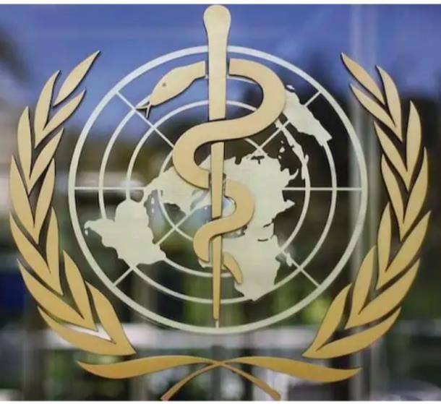
“The WHO was founded in 1948. It is the United Nations agency that connects nations, partners and people to promote health, keep the world safe and serve the vulnerable – so everyone, everywhere can attain the highest level of health

... WHO’s work remains firmly rooted in the basic principles of the right to health and well-being for all people, as outlined in our 1948 Constitution. The World
Health Assembly is the decision-making body of WHO and is attended by delegations from all Member States.” Source: https://www.who.int/about

They want you to think that they have YOUR health as THEIR highest priority.
However, they are a branch of the United Nations, and we know that the United Nations support the goals as listed on the Georgia Guidestones – the UN happens to be 666 miles from the Georgia Guidestones!
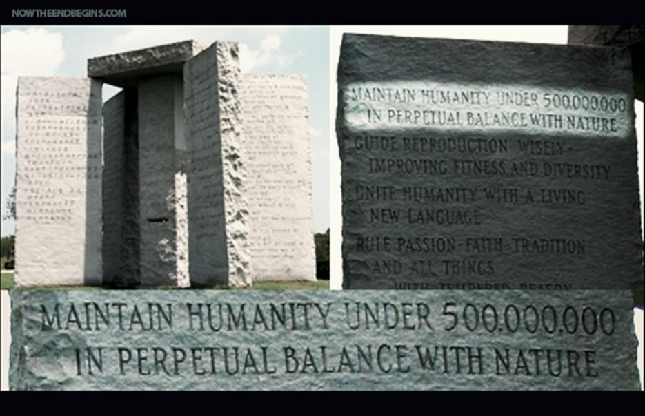

Source:elberton-georgia-guidestones-r-c-christian-10-commandments-antichrist-new-world-order-nwo.jpg
Reference:https://holybible.in/articles/georgia-guidestones-commandments-for-new-world-order/
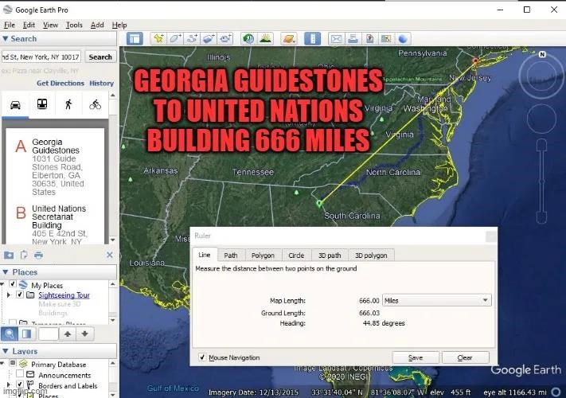

Source: https://shakingmyheadproductions.com/georgia-guidestones-to-united-nations-666-miles

In 2009, the United Nations released a World Population Report entitled “Facing a Changing World: Women, Population and Climate.” Here are a few points made in the report:
Source:http://thetruthwins.com/archives/new-u-n-report-we-must-reduce-the-population-to-fight-climate-change
- Each birth results not only in the emissions attributable to that person in her or her lifetime, but also the emissions of all his or her descendants. Hence, the emissions savings from intended or planned births multiply with time.”
- No human is genuinely “carbon neutral,” especially when all greenhouse gasses are figured into the equations. Therefore, everyone is part of the problem, so everyone must be part of the solution in some way.”
- Strong family planning programs are in the interest of all countries for greenhouse-gas concerns as well as for broader welfare concerns.

This is What They Want Us to Believe About the WHO Meeting

“Global health talks clouded by conspiracy theories about pandemic treaty”
Source: https://www.washingtonpost.com/world/2022/05/22/wha-who-pandemic-treaty/

The WHO’s 10-Year Plan for Infectious Disease 20202030

Learn to prepare your commentary and video for 16-17 June – listen to the
following video starting at 45:45. https://rumble.com/v13kefy-must-see-the-plan-who-plans-for-10years-of-pandemics-from-2020-to-2030.html

Dangers of the WHO running our world

❖ Paul Rand on Watters World – This is the danger of a one-world government

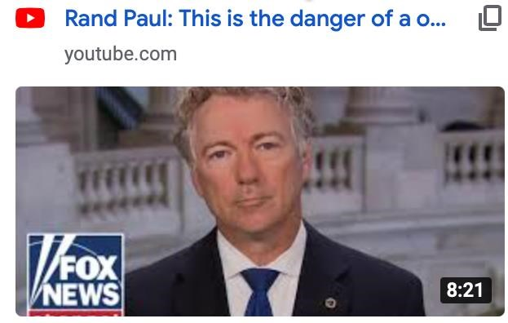

Source:https://www.youtube.com/watch?v=KknfRwyckpM

On January 18th, 2022, Smokey Joe sent the WHO thirteen (13) proposed amendments to the WHO’s Constitution. According to the WHO Constitution, as it stands right now, Article 73 states:
“Tests of proposed amendments to this Constitution shall be communicated by the Director-General to Members at least six months in advance of their consideration by the Health Assembly. Amendments shall come into force
for all Members when adopted by two-thirds of the Members in accordance with their respective constitutional processes.”
Six months from January 18, 2022 is July 18, 2022. If they voted on this any sooner, they would be going against their own legal process.

- Biden’s Proposed Changes to the WHO’s International Health Regulations

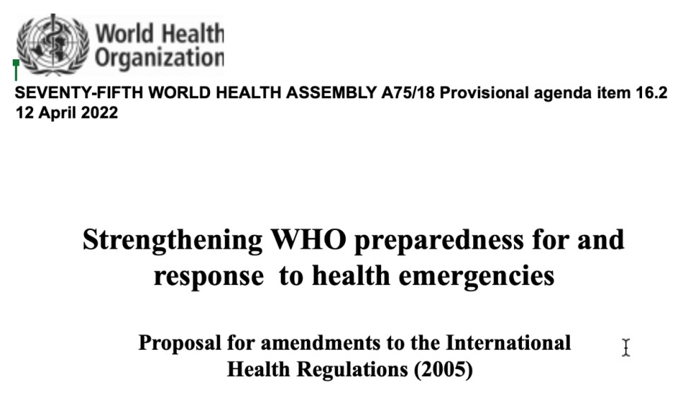

Source:https://docs.google.com/document/d/1eHulPBWx7ipDR7PgwKUmkLG_xpkIfEBuQLBGhwnyM7I/edit?usp=sharing

- Is Joe Biden About to Give the World Health Organization Authority Over the US Government?
https://www1.cbn.com/cbnnews/politics/2022/may/is-joe-biden-about-to-give-the-world-healthorganization-authority-over-the-us-government
This web page also provides a link for watching the meeting live, online.

- If Smokey Joe’s proposed amendments were passed, it would put the sovereignty of 99.4% of the world into the hands of the WHO.
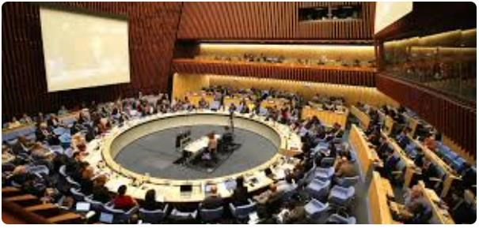

Source:Biden Handing Over US Sovereignty to WHO - America Out Loud

- Report of the Member States Working Group on Strengthening WHO Preparedness and Response to Health Emergencies to the special session of the World Health Assembly

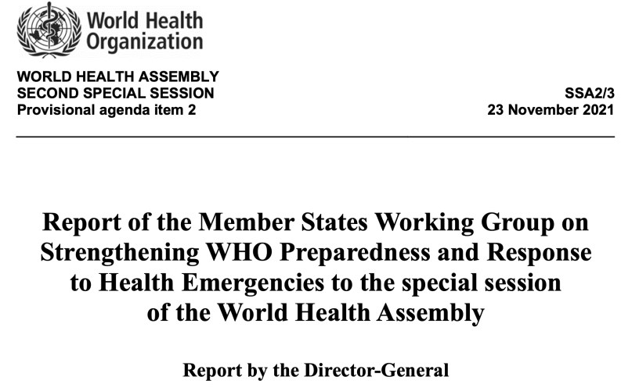

Source: https://apps.who.int/gb/ebwha/pdf_files/WHASSA2/SSA2_3-en.pdf

- Public Health Emergency of International Concern = PHOIC = FAKE. In 2017 on the last day of his term words and their meanings were changed by Obama. Watch here, especially starting around 14 minutes in: Source:https://youtu.be/fuRFfR3k1kA?t=840

- Wake up and smell the burning of our constitution:
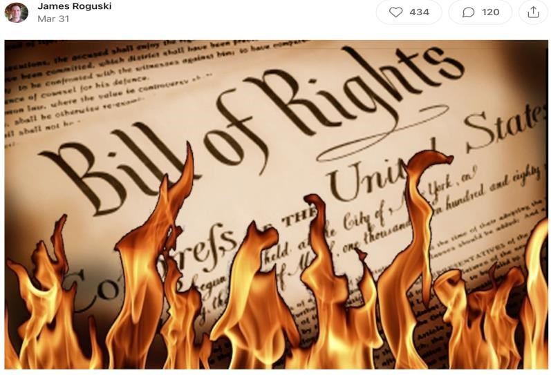
Source: https://jamesroguski.substack.com/p/wake-up-and-smell-the-burning-of?s=r

Executive Summary:
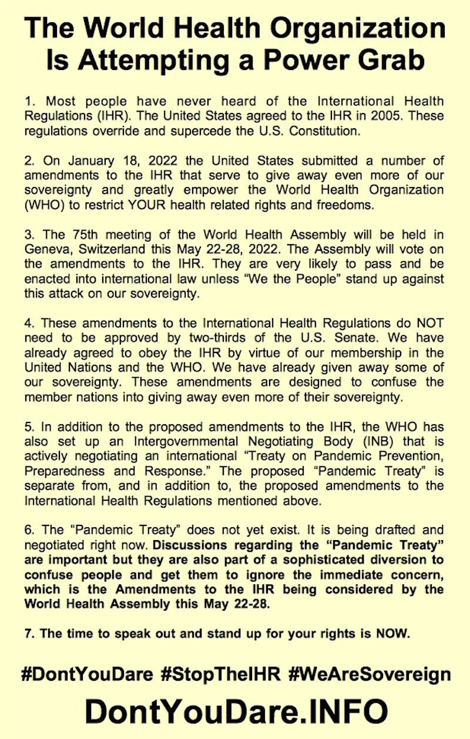

“The Supreme Court case listed below clearly shows that the Biden administration is attempting to give away powers that they are not allowed to give away.

Chan Ping v. United States, 130 U.S. 581, 609 (1889)
The powers of government are delegated in trust to the United States, and are incapable of transfer to any other parties. They cannot be abandoned or surrendered.
“‘We the People’ granted the President the right to declare a National Emergency. President Biden does NOT have the right to abdicate that responsibility and hand it over to the Dictator-General of the World Health Organization.”

Fortunately, There is Already Some Good News!

- The WHO withdrew 12 of the 13 amendments submitted by the Biden administration to alter the International Health Regulations at the World Health Assembly annual meeting.
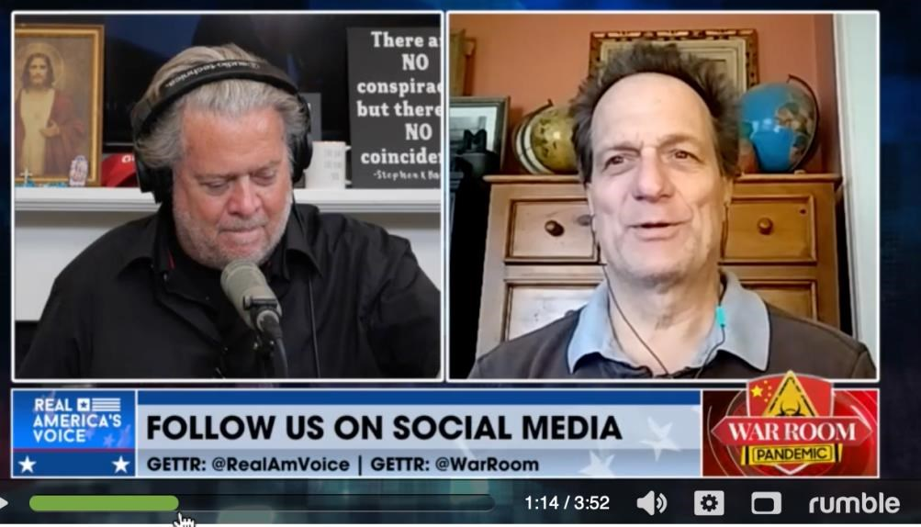

(
Click image to link to video.
)

Source:https://sarahwestall.com/5-24-who-upate-new-amendments-proposed-if-a-vote-occurs-it-will-be-in-violation-of-the-agreed-uponprocedures/
Source:https://www.thegatewaypundit.com/2022/05/world-health-organization-temporarily-withdraws-bidens-public-health-emegencyamendments/

- The WHO is being dealt major pushback by several countries, and the U.S. is pushing to create legislation preventing the WHO’s domination.
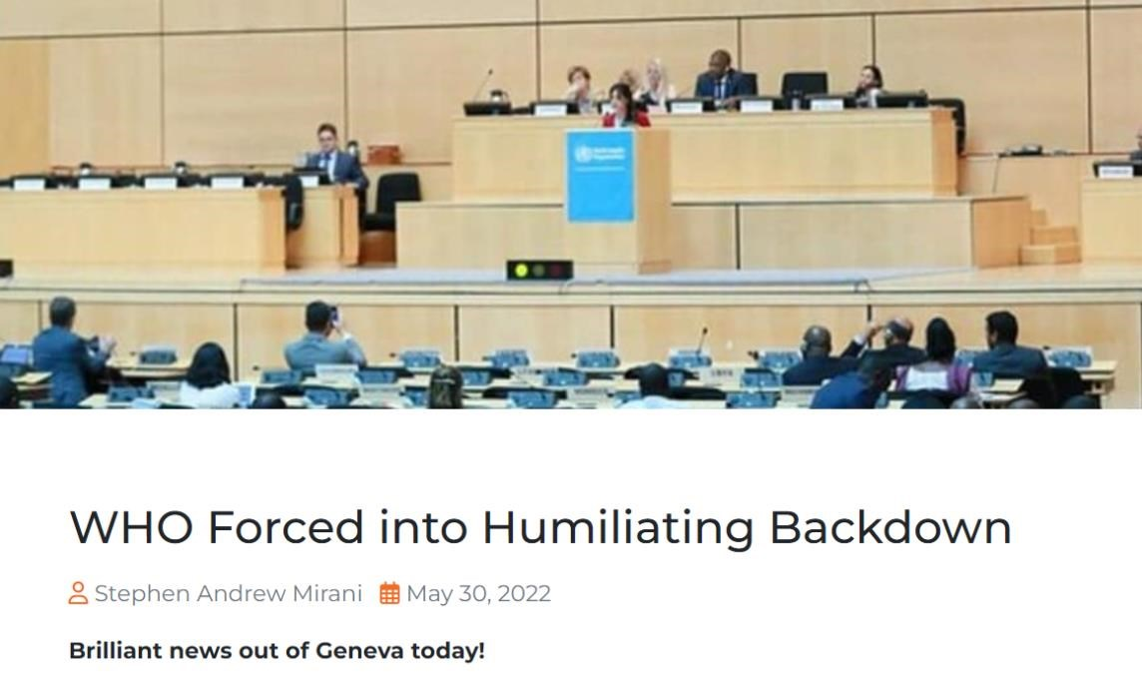

Source: https://www.onenation.org.au/who-forced-into-humiliating-backdown

May 25, 2022 - “Botswana read a statement on behalf of its 47 AFRO members, saying they would be collectively withholding their support for the ‘reforms’, which many African members were very concerned about.

“Multiple other countries also said they had reservations over the changes and would not be supporting them either.”

“These included Brazil, Russia, India, China, South Africa, Iran and Malaysia. Brazil in particular said it would exit WHO altogether, rather than allow its population to be made subject to the new amendments.

“In the end, the WHO and its wealthy nation supporters were forced to back down.”

They have not given up though – far from it. Instead, they did what they always do and 'pivoted'.

At their request, a new working group was convened to make "technical recommendations on the proposed amendments" which will be resubmitted along with the Pandemic Treaty, at the 77th Health Assembly meeting in 2024.

There has also been lots of pushback from Republicans in the US, with a number of them introducing new bills giving the US Congress/Senate powers to override any WHO mandates or directives issued as part of any international agreements.

One, called the 'No WHO Pandemic Preparedness Treaty Without Senate
Approval Act' has 15 co-sponsors and was introduced to the Senate on Thursday by Republican Senator Ron Johnson, who said "The sovereignty of the United States is not negotiable".

- Bill H.R. 419 is before Congress to Defund the WHO
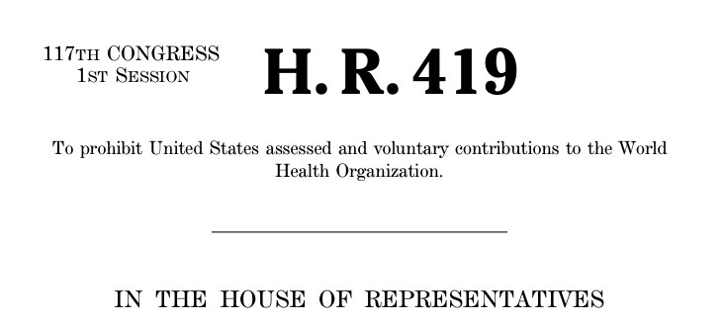

(
Click image for bill details.
)

Source: https://wisconsinspotlight.com/defunding-the-world-health-organization/ Source:https://www.congress.gov/117/bills/hr419/BILLS-117hr419ih.pdf

- N.J. Representative Chris Smith says Biden “Plans to Surrender U.S. Sovereignty to W.H.O.
Source:https://www.cnsnews.com/article/international/susan-jones/rep-chris-smithbiden-plans-surrender-us-sovereignty-who

- Governor DeSantis - There is “no way” Florida will ever support the World Health Organization’s (W.H.O.) global pandemic treaty, Florida Gov. Ron DeSantis (R) said on Monday.
Source:https://dennismichaellynch.com/watch-gov-desantis-has-bold-response-tobidens-w-h-o-global-pandemic-treaty/

- Wisconsin Senator Ron Johnson Introduces “No WHO Pandemic
Preparedness Treaty Without Senate Approval Act”
Source:https://jdfor2020.com/2022/05/wisconsin-senator-ron-johnson-introduces-nowho-pandemic-preparedness-treaty-without-senate-approval-act/

WHO Pandemic Preparedness Treaty

“It would be up to Member States to decide if and what compliance mechanisms would be included in the new instrument on Pandemic Preparedness and Response. It is a general principle of international law that once an international law instruments in force, it would be binding on the parties to it, and would have to be performed by those parties in “good faith.”
Source:https://www.who.int/emergencies/diseases/novel-coronavirus-2019/question-and-answershub/pandemic-prevention--preparedness-and-response-accord
However, the new proposed amendments to the WHO constitution would change the performance by the parties in “good faith” and instead provide a legal gateway for the UN Forces to enter a country and enforce the treaty.
Brazilian President Jair Bolsonaro declared his country would not sign onto the World Health Organization’s (WHO) Pandemic Treaty, assuring that Brazil will not surrender its sovereignty to the globalist institution.
President Bolsonaro was the only leader to oppose the pandemic treaty and rebuked Biden’s amendments, assuring his country would not surrender its sovereignty to the globalist institution.
“Brazil will not get into this [WHO Pandemic Treaty]. Brazil is autonomous,”
Bolsonaro told reporters on Thursday. “Brazil is autonomous and will not get into this, You can forget about that. I’ve already spoken to our foreign relations cabinet and if that proposal goes forward, it won’t be with Brazil.
“Moreover, I was the only statesman that didn’t adhere to the lockdown policies,” the populist president continued. “I said we had to take care of the elderly and people with comorbidities, and today studies outside of Brazil especially show that I was right.”

(
Click on the image for video.
)

Source:https://docs.google.com/document/d/1TO7E9oMIn8wjhip_I7xISlemlxL6mvPu/edit
Source:https://miamistandard.news/2022/05/22/bolsonaro-rejects-whos-pandemic-treaty-brazil-is-autonomous/

Fire Breaks Out at Geneva Airport
Their Story: “There is a building - the new reception center for asylum-seekers - which was under construction... it is on fire. It is outside the airport perimeter.
It is creating a lot of smoke. The … airport has suspended planes from landing and any decisions about take-offs are being left up to the discretion of pilots, according to reports.”
The Truth from Q the Stormrider:
FIRE AND EXPLOSIONS IN SWITZERLAND WAS RUSSIAN SPECIAL FORCES OPERATIONS. The WARNING was sent to DAVOS group, SWITZERLAND BANKS, and to EU NATO UN.
Not only are there Deep State Special forces fighting in Ukraine against RUSSIA....But now RUSSIA has SPECIAL FORCES in the EU sending a WARNING.
The explosions were NATO MILITARY supplies and munitions (military weapons, ammunition, equipment, and storages).

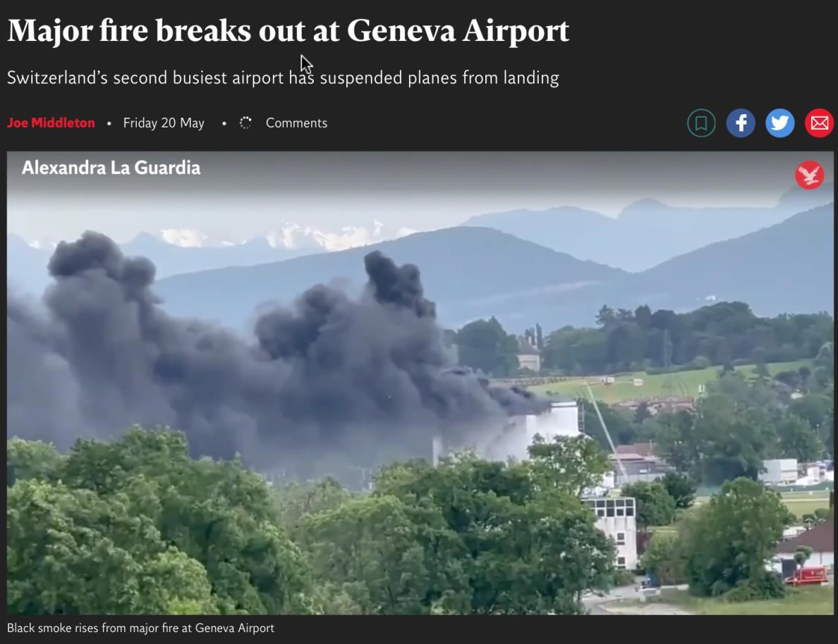
(
Click on the image for video.
)

Source: https://www.independent.co.uk/news/world/europe/major-fire-geneva-airport-b2083927.html

What You Can Do – A Call to Action!

- Call or send an email to Congress, your Senator(s), your Congressional Representatives, and send it to every media outlet on Earth and demand that they ask our elected officials what they are doing about this clear and present danger to our sovereignty. Send it 10+ times a day until you get a satisfactory response.
Source: https://jamesroguski.substack.com/p/send-this-email-to-congress?s=r
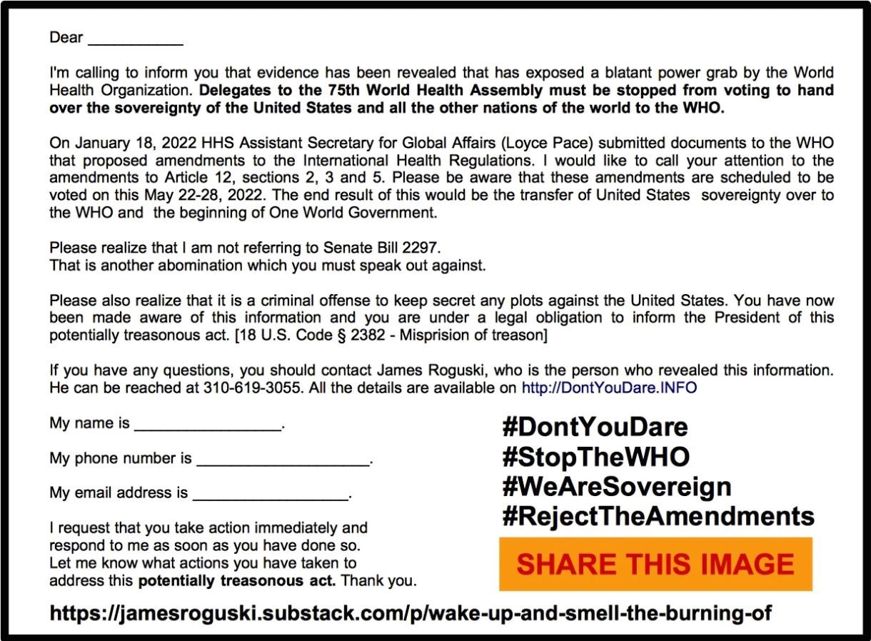

Find your Congressperson: https://www.congress.gov/members/find-your-member Contact your State Attorney General:
https://www.naag.org/find-my-ag/

- Submit your public comment the Department of Health and Human Services' Office of Global Affairs regarding the WHO’s proposed amendments to the International Health Regulations

- Vision the world the way YOU want it to be. Use your voice. Tell the one true living God of all creation, “I Do Not Consent!” Our Zoom Community rose up and made our case to the Courts of Heaven. We collectively said WE DO NOT CONSENT TO THE WHO’S PROPOSED ACTIONS. God heard us.
Listen to the visioning session we did to stop Smokey Joe and the WHO in their tracks. The more people who view this and add their “I DO NOT CONSENT” to this visioning, the stronger it gets. You can find the recording of the visioning on the Gene Decode Telegram channel:
https://t.me/RealGeneDecode
and here: https://rumble.com/v16f841-visioning-with-julie-b.-w.h.o.-global-legalpower-grab.html

We CANNOT and will NOT allow them to make these amendments.

These people are sick. They are so desperate they will do absolutely anything to try and recover as much of their NWO as they can. We the people have a choice. We can either stand back and give them our tacit agreement to launch the NWO or we can stand up and declare that we DO NOT CONSENT to their plan, and make sure they are aware that we know what they are doing and we are not okay with it any longer.
The Cabal will continue to try and bring in their New World Order. It is in their genetics not to give up on this plan, they crave power; it isn't a want, it is a need for them.
However, we know that God Wins.
“Evil thrives when good men do nothing.”

Author Unknown

For freedom Christ has set us free; stand firm therefore, and do not submit again to a yoke of slavery. Galatians 5:1
So, if the Son sets you free, you will be free indeed.

John 8:36

For you were called to freedom, brothers. Only do not use your freedom as an opportunity for the flesh, but through love serve one another. ¹⁴ For the whole law is fulfilled in one word: “You shall love your neighbor as yourself.”

Galatians 5:13-14

But if you do not forgive others, then your Father will not forgive your transgressions.

Matthew 6:15

For if you forgive others for their transgressions, your heavenly Father will also forgive you.

Matthew 6:14
Whenever you stand praying, forgive, if you have anything against anyone, so that your Father who is in heaven will also forgive you your transgressions.

Mark 11:25

But if you do not forgive, neither will your Father who is in heaven forgive your transgressions. Mark 11:26
“My heavenly Father will also do the same to you, if each of you does not forgive his brother from your heart.” Matthew 18:35
If you forgive the sins of any, their sins have been forgiven them; if you retain the sins of any, they have been retained.” John 20:23
“Do not judge, and you will not be judged; and do not condemn, and you will not be condemned; pardon, and you will be pardoned.

Luke 6:37

Our Sovereignty comes from surrendering ONLY to God and letting go of any souls that we are holding hostage. We hold people hostage when we don’t forgive them, and lose our standing to stand in sovereignty.
Our battle is not against flesh and blood; it is not against our friends, neighbors, relatives, or people on the street wearing masks. Those are all people who have been created by God. ONLY God and Jesus Christ have the right to judge.
Freedom of choice is absolute – it’s our free will give to us by God. Everyone makes his or her own choice; and everyone is also free to change their mind if and when they want. And every person who dies has the opportunity to know and love Jesus Christ even after death, so can we really know what their future holds now?
We need to be treating EVERYONE with kindness, compassion and understanding even if they aren’t doing so in return – especially if they aren’t doing so in return. We don’t know what that person has been through that led them to the moment that we encounter them.
Forgiving someone does not mean that they are being let off the hook. It means that you are releasing them to God. It means that you are no longer holding their soul hostage and finally allowing God to deal with them and the situation as he sees fit from his divine wisdom.
“Evil prevails when good men do nothing.”
This is not the time to sit on our hands and do nothing. This is a call to action.
We need to stand before God and tell Him that we do not consent. Write letters, emails or call your elected officials and make sure they know you are aware of the situation with the WHO and that it is treason for them to do nothing about stopping these amendments from being made and treaties from being formed as they are handing the sovereignty of your nation over to the WHO. Let’s tell everyone we know what is happening. If they disagree, it’s okay. Our job is to inform them AND THEN KNOW that we have done our part.
There is no reason to fear. God is in control! God allows us to make choices. If we choose to do nothing, then our choice has given the NWO our consent.
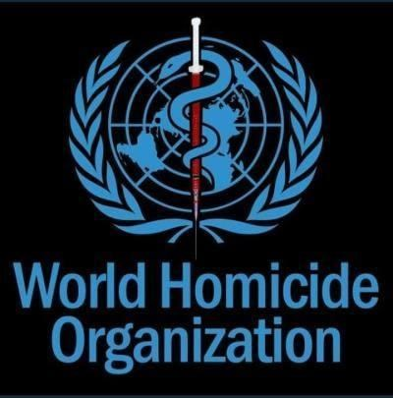

WE DO NOT CONSENT!!

I Do Not Consent (My Soul Is Mine)
https://www.youtube.com/watch?v=MZGdnz24s-A
WorshipMob - Break Every Chain
https://youtu.be/dSKSI5SHmY4

