
New York Intel: USA Et Al Are Under Tyranny
RV/War/NOW/Post-RV News and Information
Helping To Keep You In The Know and In The NOW. Patriots United.
RV is anticipated to occur between mid-2022 and end of 2023 – If you hear anything but this then it is just Noise.
Fight for your Freedom and for your Lives Now! God Wants Us To Fight Evil Now!
Post 15 by Royel Madison on January 18, 2022:
Evil has walked into our front door and our Freedom has slipped away into Tyranny and our country is being destroyed and the people are being murdered. The Constitution has been trampled on. The People Should Rise Now! Fight This Evil! Fight for your Freedom and for your lives! Royel Madison
https://operationdisclosureofficial.com/2022/01/10/new-york-intel-photo-of-an-elder/
RV and The Great Purge of Evil:

- We are still waiting and we will continue to still be waiting for a long time. Because the military is fighting itself right now. All divisions: navy, army, marines, air force and space force. There are fleets in the space force, they have been traveling great distances for decades, and they are in-fighting benevolent fleets against malevolent fleets. The military is divided. The Deep State was trying to take it over. So, we cannot overly rely on them which means that you must get off of the sidelines and fight for Freedom and Wake People and Protest and....
So, stop listening to the PsyOps because the GCR/RV is not happening anytime soon. The PsyOps are just to keep you in a trance state of mind on the sidelines. If it happens later this year then we are really lucky. But it will probably start sometime next year. I want it to happen as much as you do. So, we should all try to do something to fight back for our freedom and for our lives now.
- Wake up more people. We do this. I will soon post a Wake-Up report to share with people, it is just what I have saved so far to do so. And, sit with people to explain it to them. Ask them if they have any questions. Tell them that this war behind the scene is our freedom and that the Deep State was and still is to some degree in control but that is changing now to something beautiful that we should see by next year the latest.
Find out about Organized Protests then share this news with many others.
- 1-15-2022 President Donald Trump’s Speech, a benevolent, powerhouse leader and speaker who loves our country and our planet and the people and God.
https://rsbnetwork.com/video/watch-president-donald-trump-rally-live-in-florence-az-1-15-22/
- That is General Mao’s son in the photo I posted last week. He is one of ‘the elders’.
- SPECIAL FORCES DEPLOYED! STATE OF EMERGENCY DECLARED BY NATO AND ITS ALLIES!
https://www.youtube.com/watch?v=oLlk_iynQQo
- Some progress: U.S. Supreme Court blocks Biden's China virus (COVID) vaccine and testing mandates for businesses with more than 100 employees. Kayla is good.
https://www.msn.com/en-us/money/news/us-supreme-court-blocks-bidens-vaccine-mandate-for-businesses-with-more-than-100-employees/vi-AASKRAY
But the conservative-majority court allowed a vaccine mandate to stand for medical facilities that take Medicare or Medicaid payments.
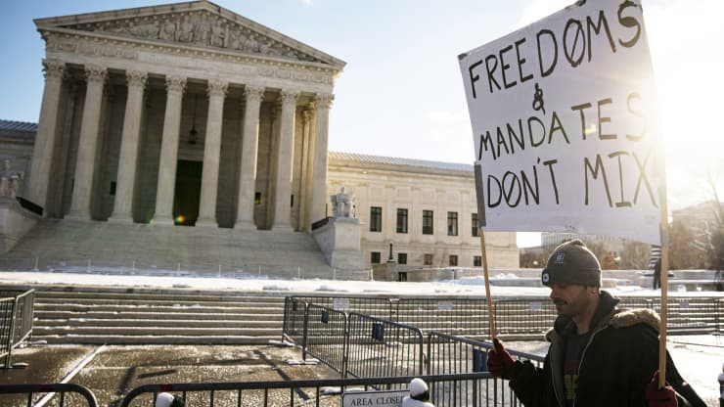
Good job Patriot! God will reward you for standing against evil. God wants us to protest like this.
- [Our Mission Is to Wake Others, So Wake Others with This Now. Share This.]
THOUSANDS GATHER AT EIFFEL TOWER IN FRANCE TO PROTEST MEDICAL TYRANNY.
France has been fighting a hard battle against the tyranny.
https://rsbnetwork.com/category/news/politics/

This is a good news source that you should keep an eye on for more benevolent news.
Big Pharma Is A Drug Cartel.
- God Wants Us to Fight Evil in This War for Planet Earth and Humanity. Be Strong. Hold The Light. Get Off of The Sidelines and Do Something. Have No Fear As We Are Immortal Souls. Make Our Father Proud.
- Where is the Militia? How could they stay on the sidelines with what is going on now? They need to get off of the sidelines and help with this fight against evil, millions are dying, our freedom has been taken away, our country is being destroyed! Fight the evil!
So, I sent an email.
Hi Buddy Stewart,
I did not speak to you in a long time when Obama was destroying the country I called and we spoke for 30 minutes.

What is going on now?
The country is being destroyed.
The people are being murdered by the vaccines etc.
The country is now under medical Tyranny.
The Constitution has been trampled on many times.
This is a dangerous environment.
Where is the Milita?
The People should also help by having many protest demonstrations.
R
We await his response.
- Keep food and supplies stocked up. This is a very messy situation that takes twist ad turn deviations from all paths, so this can easily turn into a Civil War and/or we could end up fighting another country’s malevolent military that tries to come here to help Biden.
- NYTimes Admits: CDC reports "create alarm in parents" with unfounded data on kids
https://covidreason.substack.com/p/nytimes-admits-cdc-reports-create?token=eyJ1c2VyX2lkIjozNTk2NjYwNywicG9zdF9pZCI6NDcyMTI5MjIsIl8iOiJ2Nkd2aCIsImlhdCI6MTY0MjQ2MTU1MCwiZXhwIjoxNjQyNDY1MTUwLCJpc3MiOiJwdWItNjQyOTUiLCJzdWIiOiJwb3N0LXJlYWN0aW9uIn0.9BHKDeqzhzAUqhmtT2qPVinJe35MzqlF-hlgXw_ESGY
WILL YOU ALLOW YOUR CHILDREN TO PARTICIPATE IN VACCINE GENOCIDE??? Save The Children! ORGANIZE YOUR COUNTY, CHURCH, VETERAN GROUPS, CIVIC GROUPS STATE BY STATE WHILE THERE IS TIME/ THE DEMS/SOCIALISTS VIEW THOSE WHO CHALLENGE THE VACCINE GENOCIDE, VOTING RIGHTS, ILLEGAL IMMIGRATION, GUN RIGHTS AS AN ENEMY OF THE STATE AND DOMESTIC TERRORIST. M
- THE GENERAL PATTON SAID!!!!
Peaceful Transition to Military Power
https://worthy.watch/smooth-transition-to-military-power listen carefully, at 34-second mark, Major General William Walker, the Commanding General of the District of Columbia, National Guard describes, “a smooth transition of military power.” Today on Good Morning America.

11.3 END OF OCCUPATION & DURATION OF GC OBLIGATIONS. 11.3 in the DOD Law of War Manual, is based on International Codes of War from the Geneva Convention, which must be followed by all nations. *Remember, Trump is by the book, Law & Order.* § The fact that the Democrats joined forces with China to steal the election and the Biden Administration went ahead and knowingly assumed power, that makes them a Belligerent Occupier. This is an act of War. The DOD War Manual, states that 11.3 applies to both the Belligerent Occupier and the Occupied Territory (the United States). § According to the manual, after one year of Occupation, the GC obligation will expire. § Therefore, 1/20/2022, will be one year since China and the Biden Administration took over and became a Belligerent Occupier. After this date, 11.3 will go into effect and the military then has the legal right to take over the country. A
- [Our Mission Is to Wake Others, So Wake Others with This Now. Share This.]
FINALLY - ITS ALL COME OUT! Covid19 is NOT ONLY a bioweapon- they put HIV/AIDS in it AND its designed to KEEP REPLICATING into over 180+ variants to bypass the Vaccine.... AND mRNA and the spike proteins are designed to damage the body and destroy the autoimmune system.
https://rumble.com/vqvhn1-we-knew-the-truth-would-come-out-but-this-is-worse.html
This is Biological Warfare Against The People.
- As Protests Erupt, Some Countries Backtrack on COVID Mandates While Others Double Down.
https://childrenshealthdefense.org/defender/protests-worldwide-countries-covid-mandates/
- [Our Mission Is to Wake Others, So Wake Others with This Now. Share This.]
Refresher, reminder so we will never forget.
a small group of super rich criminals have been buying virtually everything on earth, until they own it all. From media, health care, travel, food industry, governments... That allows them to control the whole world. Because of this they are trying to impose the New World Order.
Bill Gates, Klaus Schwab, George Soros, ...
https://rumble.com/vn7lf5-monopoly-who-owns-the-world-must-see.html
- [Our Mission Is to Wake Others, So Wake Others with This Now. Share This.]
This Is Excellent and Overdue: Megyn Kelly Blasts the Airwaves With Smashing Truth Bombs.
The White Hats will eventually take over it all (news media, government, courts, etc.) then they will tell the people about the widespread election fraud of corrupt politicians and judges, etc.
https://na01.safelinks.protection.outlook.com/?url=https%3A%2F%2Frumble.com%2Fvrw6eh-omg-is-this-megyn-kelly-main-stream-white-hats-now-in-control-of-the-media.html&amp;data=04%7C01%7C%7C70deb2dc0f35497d3be308d9d16d9e16%7C84df9e7fe9f640afb435aaaaaaaaaaaa%7C1%7C0%7C637771090991658045%7CUnknown%7CTWFpbGZsb3d8eyJWIjoiMC4wLjAwMDAiLCJQIjoiV2luMzIiLCJBTiI6Ik1haWwiLCJXVCI6Mn0%3D%7C3000&amp;sdata=T6NvF7T5PKG%2FZvLHbjxSWQbfD4O8lo1UQoNQNdEO4rA%3D&amp;reserved=0
Do not take any more vaccines please.
- [Our Mission Is to Wake Others, So Wake Others with This Now. Share This.]
Pray. Pray often. Know or learn how to pray or just speak to God from your heart.
I utilized The Holy Bible and The Book of Enoch to create this prayer.
We need to get off of the sidelines now and get in this war in a dynamic and results driven manner to drive this to an ending so that we can have our beginning of a new benevolent earth with humans reaching their full potential without malevolent suppression.
For this we ask for the help of Jesus Christ, the Holy Spirit and I Am, I Am That I Am, the Father, YHWH [Yod-Hey-Wod(Vod)-Hey].
Pray numerous times daily with your utmost focus of attention without diversion/deviation which enables us to utilize consciousness to ensure that the message will get through to the divine realm.
This prayer combines the authorized King James Version of The Holy Bible and The Book of Enoch, i.e., since Enoch should be in the bible but it is not).
[Find a quiet time and place with no disruptions. Pray in private. Address the Father e.g. “Oh Heavenly Father” or can be Can also address the Father, the Son Jesus Christ and the Holy Spirit or either of the Holy Trinity; or, We pray to our Heavenly Father, in the name of Jesus Christ, by the power of the Holy Spirit. Be humble and sincere. A prayer can be telepathically, not spoken, or spoken. Express your Love to God. You can seek what God wants you to do, then ask for what you need. He wants to test us, to strengthen us and to help us achieve our full potential. He may say no since these things give us experience and or shall be for thy good. Close the prayer: In the name of the Father, the Son and the Holy Spirit. Amen. We must pray sincerely from the heart and often.]
The Prayer I Recently Created:
Kodoish, Kodoish, Kodoish, Adanai ‘Tsebayoth. [Holy Holy Holy Lord God of Hosts.]
I Am That I Am [Ehyeh Asher Ehyek].
YHWH [Yod-Hey-Wod(Vod)-Hey], the Holy Spirit and Jesus Christ.
Heavenly Father. [God has many names.]
Thank you for this human experience and for all that you provide. I Love You very much.
Thank you for your love and for your light.
There is much evil here on earth which we will fight as you want us to do so.
You have recently sent much light energy here which we will try to utilize for this purpose.
We also ask for more help in this urgent matter.
Please remove the evil from this planet.
Please give us our freedom and enable us to live in a benevolent environment.
Please stop the intentional murdering of millions of humans by the evil ones.
Please ascend us humans who are ready or want to go to the fifth dimension or beyond.
Deliver us from evil.
I look very forward to continuing this human experience in a benevolent environment which will be very much different, much better than it is now.
Thank you very much. I Love you very much.
For thine is the kingdom, and the power, and the glory forever.
In the name of the Father (I AM), the Son (Jesus Christ) and the Holy Spirit. Amen.
[Then try to utilize the light energy that was recently sent to earth from the divine to remove the evil from this planet.]
[Next, envision your near future under a benevolent environment. Thought will create it.]
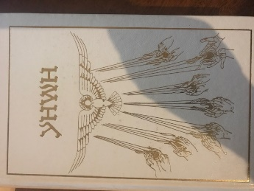
- [Our Mission Is to Wake Others, So Wake Others with This Now. Share This.]
Benjamin Intel, for an international flair, it’s good info this time:
A rogue AI that controls the Khazarian mafia. Humanity must defeat this AI or become slave-robots working eternally to serve a machine mind.
Schwab has been apparently replaced by an AI.
The WEF World Economic Forum brag “The global COVID-19 crisis has acted as a worldwide accelerator for the rollout of artificial intelligence (AI) initiatives.”
https://www.weforum.org/events/the-davos-agenda-2022
WHO, IMF and the World Bank are working together in order to provide extra financial support to the WHO and its COVAX partners for “providing all countries with equal access to vaccination.”
The WEF wants to impose on humanity in a large portion of these vaccinations nanobots allowing remote control of humans by an AI. Using neural nanobots to connect to the human brain’s neocortex.
The person appearing as Fauci on TV screens is definitely an AI avatar because the real Fauci was executed.
The entity masquerading as the [Biden] administration’s surgeon general, Vivek Murthy, is not a man but computer-generated imagery (CGI) superimposed on a dynamic algorithm.
A massive counter-attack against this AI and its brainwashed human servants is now underway.
https://benjaminfulford.net/2022/01/17/the-gnostic-illuminati-was-right-we-really-are-dealing-with-a-rogue-ai/
- Contact gun stores and veterans’ groups etc. to ask where is everyone organizing to fight this evil to fight for the Constitution, for our freedom and for our lives. Then find out what they are doing to make a stand. Is it a verbal or a physical stand… And, organize locally by town, regionally by county, by state and nationally. We are fighting for our lives now! Do not over rely on any others. You see millions of people are dying. Help to stop this madness now! Call the militias. Organize. Do somethings now. If there is no one in your area organizing then start it. Create flyers leave them around where people can see them and post them on posting boards.
- [Our Mission Is to Wake Others, So Wake Others with This Now. Share This.]
COVID Treatments Online
https://americasfrontlinedoctors.org/covid/treatment-options/
- 1-13-2022 Donald J. Trump, Great President of the United States of America
The Supreme Court has spoken, confirming what we all knew: Biden's disastrous mandates are unconstitutional. Biden promised to shut down the virus, not the economy but he has failed miserably on both—and mandates would have further destroyed the economy. We are proud of the Supreme Court for not backing down. No mandates!
- 1-11-2022 Donald J. Trump, Great President of the United States of America
Stacey Abrams helped Biden steal the 2020 Election in Georgia but now she won’t even share a stage with Joe. Stacey knows that Biden actually lost BIG in Georgia, and in the 2020 Presidential Election as a whole, and he’s been so terrible she now wants nothing to do with him. Even the woke, radical left realizes that Joe Biden’s Administration is an embarrassment!
- [We have heard so many intel providers lying so many times before. Stop the PsyOps Lies Now as the people deserve much better. The RV is not starting anytime soon. Fact.]
- Folks, understand that there is much more work to be done. This is a war and wars take a long time to resolve. So, an RV cannot and will not be any time soon. Understand that you are being lied to when someone tells you otherwise. Anticipate it to occur by mid-2022 the earliest and by the end of 2023 the latest; however, we will periodically revisit this timeline.

“We The People Allowed Tyranny To Happen By Over Relying On Elected Officials When We Should Have Had An Organized Civilian Population To Watchdog Our Government. Henceforth, We Must Now Start And Maintain Ongoingly A Very Large Civilian Watchdog Organization Here In The USA While Showing Other Countries How To Do The Same. This Must Be Done Without Haste.”
Royel Madison

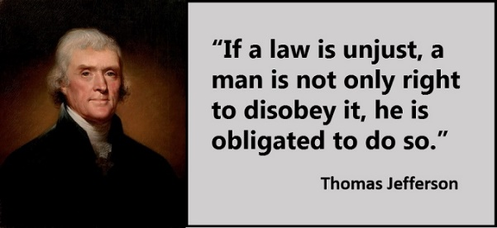

- “I’m fighting every second of every day to SAVE AMERICA.” Great President Donald J. Trump 11-28-2021. We are very grateful for this brave man.

- Get your minds good and ready for the Second Amendment to be realized! If the military cannot get the job done timely, the militia most certainly will and there are other methods! Get in the fight!

- I am ready and would very much like to establish friendship and a networking relationship with very good, highly intelligent Pleiadeans, so please do contact me as soon as possible. There is much to discuss yet we can start slowly if your time is limited. Thank you kindly for the opportunity. Some say that Pleiadeans may be humans that have advanced into 5D.
- Have Patience for the RV prize but Act for our Freedom now! – we are Lightworkers here for this purpose and are being utilized in the PsyOps part of this epic war. But get involved more to help make it happen sooner.
- Be Prepared – our turn to go is in the final stages once we get the go ahead so be ready to follow through on your mission. Periodically review your materials for improvements and to stay fresh with it, manifest it into a reality. Always be prepared to make your bonds/currency delivery and to start benevolent projects.

God Bless The World
God Bless America and Our Commander In Chief Trump

Post RV and In The Now Moment: Stop eating so much popcorn! You all must surely be tired of all the pump fakes, so let us do something different while we still stay informed and prepared for NESARA.
- The people need to United in an effort to make and keep this world a beautiful place.

Imagine. John Lennon Memorial in Central Park NYC UWS.
- Start using your powerful abilities of creating reality from our Collectively Focused Thoughts. Thought creates Matter. Thought creates Our Reality. Focus more on post-RV to help it transpire. The RV is the symbol for evil being removed from our planet. And, daily praying helps.
- Do perform daily thought/intention manifesting into our reality our goals as humanitarians by thinking more about the projects and post-RV life, others’ projects, new technologies, exponential human evolution, and how beautiful the world will become.
- Do perform daily thought/intention manifesting 5D into our reality while we keep one foot in this 4D experience. (We are currently in 4D not 3D. Time is a dimension providing unidirectional movements etc.)

Mind travel through space time. Ascension exodus. It is now our time to shine which is written in the stars (more on this topic with our Cycles and Program analysis in an upcoming next post).
- Do perform daily thought/intention manifesting that evil be removed/recycled from our planet. Pray!
- Do focus daily thought/intention manifesting Love into our reality which is the most powerful force in our universe.
- Do perform daily Thought manifestations into our Reality often to bring this to an end and create a beautiful world. We may be coordinating group sessions in the near future since this is very important to helping ensure that our Freedom and Ascension are realized.

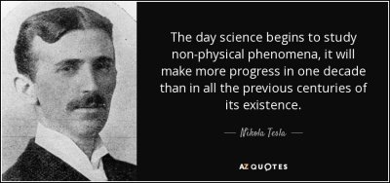
“The day science begins to study non-physical phenomena; it will make more progress in one decade than in all the previous centuries of its existence.” Nikola Tesla
A great man whose knowledge was suppressed by the evil Kabal. Imagine what a world this would be if he and so many others were allowed to thrive which will be the case post-RV. Imagine that.
Also, I believe as does physicist Richard Feynman that humans need to combine biology with physics to better understand the universe. We have such a long way to go, so much to explore, to understand and to evolve; humans are infantiles.


Thoughts become things.
_____________________

Messages From C,

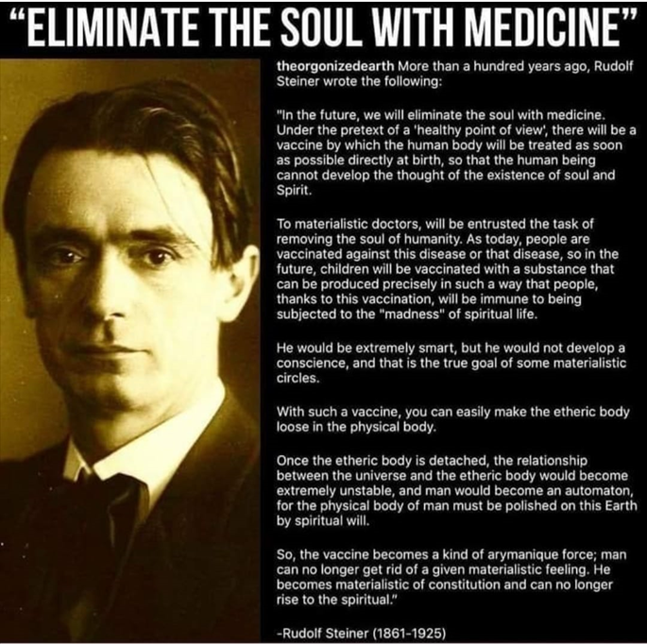

_____________________

Messages From Earth Angel Bev,


Yes, it is a great honor to be here in the moment.
Something immensely powerful just occurred,
this was fascinating to feel
it knocked me for six seven eight and nine!
and a soft lavender was used all around and to close the circle. Bev

[God’s Light
Is creating the rebirthing of earth.
The light is strong.
It is removing evil,
bringing freedom and peace and love and joy and a new beginning.
This is biblical and we are witnessing it.
It is written in the stars for this time and place…
cycles and programs…we are being programmed for the new beginning.
We are starting a new cycle. R]

(Many will see different; all interpretations are correct in their perspective. muchLove. InJoy.) 🙏🏻💝 Bev
[What do you see, feel, receive, ident, perceive? R]
_____________________

Many of the RV intel providers are benevolent and combine to carry the Light; the dark is finished, their days are numbered, they never did achieve their dreams. They are being rounded up now. Thank God!!

Royel Madison is a Contributing Writer and a Lightworker here for the human experience and for The Great Transformation on Earth which is now removing evil from earth and elevating us to 5D+, The Big Galactic Show. What an honor it is to be here at this very special time. Thank you and God Bless you.
The above information includes research, analysis, conversations, experts, opinions, etc. for the week. We are benevolent and truthful, so we try to eliminate the PsyOps of lies that you may be getting from other sources to put you in a trance state so you stay quiet on the sidelines but you should be in this fight for freedom and our lives.

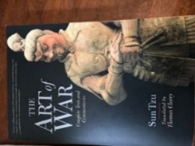
Strategic psychological operations are a normal part of warfare.
We, however, are not accustomed to being a part of a war - stay strong, hold the Light.

Truth and Courage
Truth and Courage are what evil fears. Stop eating so much popcorn on the sidelines, and help carry the Light in this epic war. Utilize your powerful abilities as co-creators by making our Physical Reality from our non-physical Thoughts. Thought Creates Matter. Thought Creates Our Reality. Envision Post-RV often to help ensure that it happens. Focus as much on post-RV as you do on the RV. Also, Unite, Organize, Make Plans and Actions to help in this epic Great Purge of Evil and do help people in need around you.

Stay Strong and United
Help the homeless and others please. The good among us shall help those whom evil has harmed.
Please be generous with your time and your money, now is the time to do so. So many lives have been destroyed because of the criminal enterprise. Find those in need, they are many and are all around during these crazy times, then help them as much as you can. We are benevolent souls. Help change over this world to Good - help to make our planet a beautiful place. This is a war between Good and Evil; Evil is doing very bad things and we the Good need to do more good deeds.
Spread the Love. Share whatever you can.
Love and Compassion in Action! We All Must Do (Not Just Say) Now.
Now is the time to help others. Please help homeless, food pantries and others as soon as possible.
_____________________

We could use some financial assistance so that we could do more to help.
We also have information, files, videos, etc. that need to be upload to a website which will help many people. Thank you.

Disclaimer:
Much of the above information was obtained from various sources which should be taken with a grain of salt. It is entirely up to the reader to determine if this information is accurate or not, so without blindly believing the information herein, and knowing that much warfare psychological operations and/or erroneous data can be included in the herein information, readers need to do their own fact-checking research to determine what information is and is not valid, i.e., do not rely on this information for any reason.

When our day to perform actually comes, the Safe Link Website information will be made available in many places, including in our posts and on our website. Let us all help to spread awareness and move things forward to a significantly brighter, beautiful future for humanity, for other life forms and for our living being planet. The information provided herein is not for the timid. For entertainment purposes only. FREEDOM!!!
_____________________

Well Knowledgeable, Well Networked and Well Informed

_____________________


Freedom is not free; fight for it!
Painting of our founding father and first President of the United States, Great President George Washington crossing the frozen Delaware River at night in sleet and snow on December 25, 1776 for our independence from Britain in the American Revolutionary War.



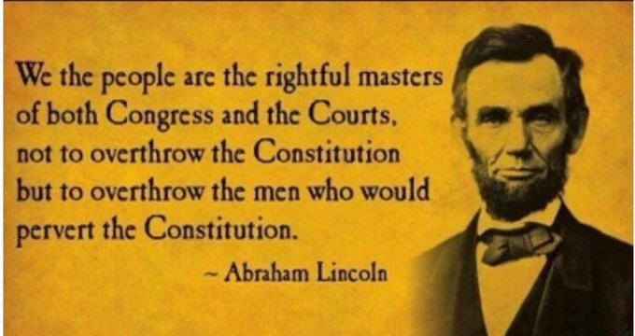
Congress and the courts have been overthrowing the Constitution, taking away our freedom and killing us by the millions. So, what are you going to do about it?

We the people are the rightful masters of both Congress and the Courts, not to overthrow the Constitution but to overthrow the men who would pervert the Constitution. – Great President Abraham Lincoln

Do not allow any entity to override The Constitution. Do not sit idle if and when they do – have the wisdom and courage to rise and do something about it. Now is that time. – Royel Madison
_____________________

