New York Intel: Patriots United
12-9-2021 Special Report: Outer Space

Outer Space and Humanity’s Bright Galactic Future
Royel Madison is a Contributing Writer and a Lightworker here for the human experience and for The Great Transformation On Earth. What an honor it is to be here at this very special time. Thank you and God Bless you.

There are already manned bases on Mars and on Ceres (a dwarf planet or asteroid between Mars and Jupiter) and probably at other places. We are already travelling throughout the solar system and beyond…well the Deep State and the military do, which is top secret and suppressed information. We are a much more advanced civilization than what the Deep State and the military have allowed us to believe. So much technology has been suppressed that we should at least be living like The Jetsons now.

Most people rely on the news media for their main source of information. However, the main stream news media is owned and controlled by the Deep State which constantly lies to the public. The people are brainwashed by it, so the people do not know what is really going on around them. TV is a form of psychological warfare. So, we need a benevolent news media for the people now to help the people now!!! This is probably why the people are not nearly ready for ETs to be amongst us. Personally, I would prefer to be around Pleiadeans and ask that they please do contact me now because I am ready to be friends.

The Deep State has been trying to weaken the USA and strengthen China to make it the new superpower. China already has a space force and so does Russia, these two countries formed a space alliance. China made an announcement that it was now seeking to exploit USA vulnerabilities in space. The USA Navy and the USA Air Force have had space forces with advanced antigravity and/or electromagnetic propulsion space crafts. Many saucers, triangular, rectangular etc. shaped craft were constructed by Lockheed, Boeing and others. Some can travel at almost limitless speeds. We have been reverse engineering UFO spacecraft and other advanced technologies since the 1920s. Even after WW2 part of Germany continually maintained its space fleet in Antarctica. And, since there are many alien species (good and bad ones) around us some of them have been helping us.

The Deep State has other names and sub-groups: The are Deeply embedded in our governments etc., New World Order, invisible government, shadow government, etc. Thirteen families lead the Deep State which are satanic/lucifer bloodlines and ET mix bloodlines. The Book of Enoch confirms that fallen angels and ETs came here to our planet. The Bible may also call them demons. Satan is their leader. The Deep State uses blackmail, coercion, false flags and many other methods to manipulate countries’ governments, organizations, corporations, news medias and ultimately the people. The Deep State has been around since ancient Egypt and even earlier. They are the invisible government that have been actually in charge behind the scenes. They also own most large corporations and put their people into positions of power. They have a human slave trade operation in space with ETs, per Corey Goode, which needs to end. The people need to know this information now.

Defense Advanced Research Projects Agency DARPA and CIA run Project Pegasus has been doing teleportation and time travel – both viewing and actual physical time travel. Today the USA and alliance are the leaders in space military etc. But this lead needs to be constantly maintained so as to deter any aggression from China, Russia or others. And, space is still the new Wild West which needs to be tamed so that no harm comes to anyone who travels in space. Do No Harm should be the main space law.

The USA military knew about the Deep State for a long time. So, for a long time they have been planning to do something about them. The military selected Donald Trump, informed him what was going on, and asked and encouraged him to become the USA President. Then Trump would lead the military against the Deep State as is being done now.

President Trump announced a new, official Space Force to protect USA and its allies, which started December 20, 2019. Members of Space Force are called Guardians. One of its first priorities is to protect the satellites in orbit and the people on our planet from the new high ground of space. And, establishing and maintaining relations with more advanced galactic species will go a long way in maintaining peace among ourselves both here on our home planet and in space. And as you are aware there is a world war going on now between the Deep State and allied forces. This war extends into space. Space Force also helps to keep space a benevolent and lawful environment when/if necessary, etc.

The government declassification and further development of many secret technologies and patented inventions suppressed will soon be declassified so that civilians can utilize them as well as governments do, e.g., stargates, energy, warp drives, medical and others. Space also offers many opportunities including but not limited to space travel/tourism, space mining, space trading with benevolent life forms, building space relations with others, civilian space colonization which helps spread out the human race to protect humans from an Earth extinction event, visiting other advanced civilizations while building relations and sharing knowledge with them, helping to keep space a benevolent and lawful environment when/if necessary, etc.

There are dozens of different species of ETs around us. The military has had space fleets for a very long time and are working on expanding and significantly upgrading them now with a little help from some of our ET friends. These space fleets travel throughout our Milky Way galaxy. Perhaps one day humans will be part of a large galactic alliance with many species of benevolent life forms.

A USA Space Corps tried to start earlier, on 9-10-2001, however, on 9-11-2001 a false flag event was started by the Deep State - the NYC world trade center twin towers buildings were disintegrated, for the most part, by direct energy weapons that already existed in space under control of the Deep State. These buildings did not burn nor crash to the ground, but mostly vaporized before hitting the ground. It was proved that the smaller Building 7 was a controlled demolition. Yet the Deep State blamed the Middle East for this so that all funds can be diverted away from a new space force to a Middle East false flag war. And since then, $trillions have moved away from the USA defense budget to the $2 trillion annually CIA official and/or unofficial black budgets (which created a space force for the Deep State’s intergalactic travel and trade etc. purposes). So, there was a long delay until December 20, 2019 when it was passed by Congress and signed by President Trump for the Space Force to officially begin. During those eighteen years, China and Russia and Deep States’ space forces all got stronger. Both China and Russia now have advanced technologies in space that are capable of destroying the USA satellite systems. The Deep States’ space force is of concern to the new USA Space Force…yet perhaps our benevolent advanced dimensional friends either can or already did help us with this very important issue. Nevertheless, space indeed requires a military presence to at least deter criminal activities from occurring within our domain. Our future in space is indeed very bright as we are at the beginning of a very exciting Star Trek future!!

The Artemis Accords will describe a shared vision for principles, grounded in the Outer Space Treaty of 1967, to create a safe and transparent environment which facilitates exploration, science, and commercial activities for all of humanity to enjoy. As of October 2021, 13 countries have embraced the Artemis Accords: Australia, Brazil, Canada, Italy, Japan, Luxembourg, New Zealand, Poland, the Republic of Korea, Ukraine, the United Arab Emirates, the United Kingdom and the United States.
https://www.nasa.gov/specials/artemis-accords/index.html
https://www.nasa.gov/specials/artemis-accords/img/Artemis-Accords-signed-13Oct2020.pdf

Royel Madison is a Contributing Writer and a Lightworker here for the human experience and for The Great Transformation On Earth. What an honor it is to be here at this very special time. Thank you and God Bless you.

_____________________

Well Knowledgeable, Well Networked and Well Informed

Stay Strong and United

Truth and Courage

Love and Compassion in Action! We All Must Do (Not Just Say) Now
_____________________

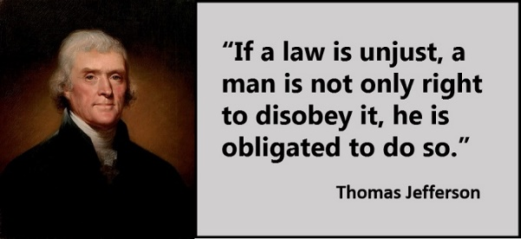
_____________________

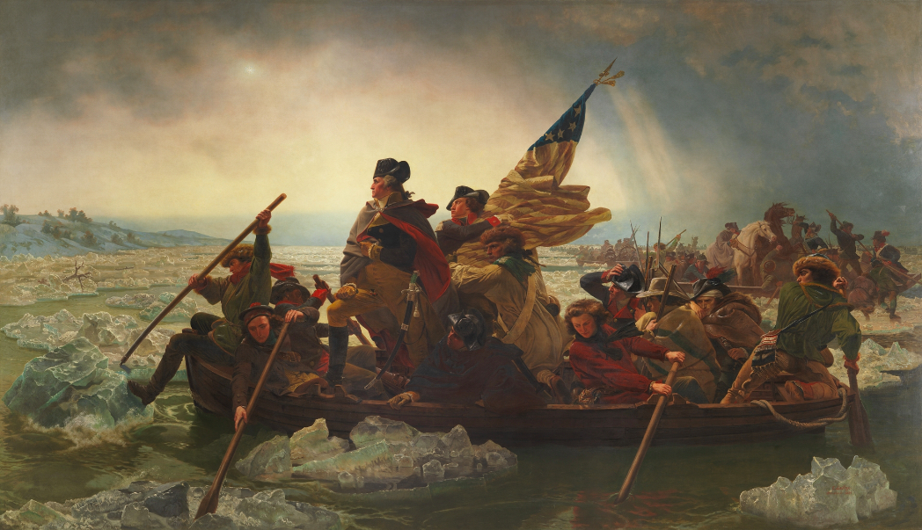
Painting of our founding father and first President of the United States, Great President George Washington crossing the frozen Delaware River at night in sleet and snow on December 25, 1776 for our independence from Britain in the American Revolutionary War.

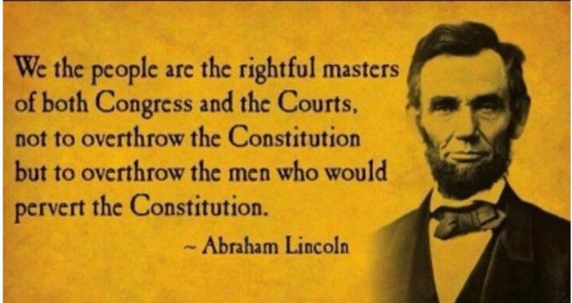

We the people are the rightful masters of both Congress and the Courts, not to overthrow the Constitution but to overthrow the men who would pervert the Constitution. – Great President Abraham Lincoln

Do not allow any entity to override The Constitution. Do not sit idle if and when they do – have the wisdom and courage to rise and do something about it. Now is that time. – Royel Madison

_____________________

